SEBI

BULLETIN

SEPTEMBER 2020 VOL. 18 NUMBER 9

(LOGO)

SECURITIES AND EXCHANGE BOARD OF INDIA

EDITORIAL COMMITTEE

Shri Amarjeet Singh

Dr. Prabhakar R. Patil

Shri Prabhas Rath

Ms. Deepthi L.S.

Dr. Deepali Dixit

Shri Jitendra Kumar

The Securities and Exchange Board of India Bulletin is issued by the Department of Economic and Policy Analysis, Securities and Exchange Board of India under the direction of an Editorial Committee. SEBI is not responsible for accuracy of data/information/interpretations and opinions expressed in the case of signed articles/speeches as authors are responsible for their personal views. SEBI has no objection to the material published herein being reproduced, provided an acknowledgement of the same is made. A readable version of SEBI Bulletin is available at http://www.sebi.gov.in. Further, soft copy of SEBI Bulletin is available free of cost to the subscribers/readers, who register at bulletin@sebi.gov.in along with their complete address. Any comments and suggestions on any of the features/sections may be sent to bulletin@sebi.gov.in

CONTENTS

CAPITAL MARKET REVIEW

REVIEW OF GLOBAL FINANCIAL MARKETS

HIGHLIGHTS OF DEVELOPMENTS IN INTERNATIONAL SECURITIES MARKET

POLICY DEVELOPMENTS AT SEBI

REGULATORY ACTIONS TAKEN BY SEBI

TABLES

PUBLICATIONS

CAPITAL MARKET REVIEW

- Trends in Resource Mobilisation by Corporates

Table 1: Fund Mobilisation by Corporates (₹crore)
Particulars | Jul-20 | Aug-20
A. Funds Mobilisation through Public Issue (I+II) | 16,070.6 | 6,107.8
I. Equity Public Issue | 15,910.6 | 6,107.8
a. IPOs (i+ii) | 510.8 | 11.5
i. Main Board | 496.2 | -
ii. SME Platform | 14.5 | 11.5
b. FPOs | 15,000.0 | -
c. Equity Rights Issue | 399.8 | 6,096.3
II. Debt Public Issue | 160.0 | -
B. Funds Mobilisation through Private Placement | 50,844.2 | 1,03,890.2
1. QIP/IPP | 2,000.0 | 42,725.0*
2. Preferential Allotment | 882.5 | 2,746.0
3. Private Placement of Debt | 47,961.7 | 58,419.2
Total Funds Mobilised (A+B) | 66,914.7 | 1,09,997.9
Note: *Includes warrants of HDFC Ltd of ₹3,999.99 crore
Source: SEBI, NSE, BSE and MSEI

- During August 2020, there were two SME IPOs equity issuance mobilizing ₹11.5 crore while the funds mobilised through rights issues was ₹6,096.3 crore.
- There were no public issues of corporate bonds in the month of August 2020. However, during July 2020, there was one public issues of corporate bonds amounting to ₹160.0 crore.
- The amount raised through private placement of equity (i.e., preferential allotment and QIP route) was ₹45,471 crore during August 2020, compared to ₹2,882.5 crore in July 2020.
- Private placement of corporate debt reported to BSE and NSE stood at ₹58,419.2 crore during August 2020 compared to ₹47,961.7 crore in July 2020.

- Trends in the Secondary Market

- At the end of August 2020, Nifty 50 closed at 11,388, registering an increase of 2.8 per cent as compared to the 11,073 level at the end of July 2020.
- S&P BSE Sensex closed at 38,628 at the end of August 2020, registering an increase of 2.7 per cent as compared to the 37,607 level at the end of July 2020.
- Both, Nifty 50 and S&P BSE Sensex reached their intraday high for the month, on August 28, 2020 with closing values of 11,648 and 39,467, respectively and their intraday low for the month, on August 03, 2020 with closing values of at 10,892 and 36,940, respectively.
- The P/E ratios of S&P BSE Sensex and Nifty 50 were 27.9 and 32.3 respectively, at the end of August 2020 compared to 24.7 and 30.2, respectively, a month ago.

Table 2: Snapshot of Indian Capital Market
Description | Jul-20 | Aug-20 | Percentage Change Over Month
Index in Equity Market
Sensex | 37,607 | 38,628 | 2.7
Nifty 50 | 11,073 | 11,388 | 2.8
Nifty 500 | 9,036 | 9,372 | 3.7
BSE 500 | 14,346 | 14,890 | 3.8
Nifty Bank | 21,640 | 23,754 | 9.8
Nifty IT | 18,072 | 17,929 | -0.8
BSE Healthcare | 18,285 | 18,388 | 0.6
BSE FMCG | 11,445 | 11,348 | -0.8
Market Capitalisation (₹ crore)
BSE | 1,47,39,116 | 1,53,76,303 | 4.3
NSE | 1,46,29,659 | 1,52,34,207 | 4.1
P/E Ratio
Sensex | 24.7 | 27.9 | 12.9
Nifty 50 | 30.2 | 32.3 | 6.9
No. of Listed Companies
BSE | 5,399 | 5,413 | 0.3
NSE | 1,941 | 1,943 | 0.1
Gross Turnover in Equity Segment
(₹ crore)
BSE | 80,093 | 93,080 | 16.2
NSE | 13,48,521 | 12,82,557 | -4.9
Gross Turnover in Equity Derivatives Segment (₹ crore)
BSE | 6,02,513 | 18,48,117 | 206.7
NSE | 4,39,35,708 | 3,94,29,369 | -10.3
Gross Turnover in Currency Derivatives Segment (₹ crore)
BSE | 4,37,166 | 4,51,790 | 3.3
NSE | 9,43,396 | 9,76,864 | 3.5
MSEI | 4,064 | 5,291 | 30.2
Gross Turnover in Interest Rate Derivatives Segment (₹ crore)
BSE | 4,082 | 1,339 | -67.2
NSE | 11,478 | 8,836 | -23.0
Source: NSE, BSE and MSEI

Figure 1: Movement of S&P BSE Sensex and Nifty 50 during August 2020

Note: The closing values of Nifty 50 and Sensex have been normalised to 100 on August 01, 2020.

- The market capitalisation of BSE and NSE registered an increase of 4.3 per cent and 4.1 per cent, respectively, over the level at the end of last month.

Figure 2: Trends in Average Daily Values of Nifty 50 and NSE Equity Cash Segment Turnover

- During August 2020, the gross turnover in the equity cash segment at BSE increased by 16.2 per cent from the previous month. However, the gross turnover in the equity cash segment at NSE reduced by 4.9 per cent during the same period.

Figure 3: Trends in Average Daily Values of S&P BSE Sensex and BSE Equity Cash Segment Turnover

- During August 2020, except for S&P BSE Teck and S&P BSE FMCG, all other BSE indices registered positive returns over July 2020 levels. The average daily volatility and monthly returns of BSE sectoral indices for August 2020 are given in Figure 4.

Figure 4: Performance of BSE Indices during August 2020 (per cent)

- All NSE indices, except Nifty Next 50, Nifty IT, Nifty FMCG and Nifty Pharma, registered positive returns during August 2020, over the previous month. The average daily volatility and monthly returns of NSE sectoral indices for August 2020 are given in Figure 5.

Figure 5: Performance of NSE Indices during August 2020 (per cent)

- Trends in Depository Accounts

- At the end of July 2020, there were 203 lakh demat accounts at NSDL and 250 lakh demat accounts at CDSL. Till the end of August 2020, 5,620 listed companies were signed up with NSDL and 5,709 listed companies were signed up with CDSL to make their equity holdings available in dematerialised form.

- Trends in Derivatives Segment

- Equity Derivatives
Table 3: Trends in Equity Derivatives Market
Description | NSE |  |  | BSE
 | Jul-20 | Aug-20 | Percentage Change Over Month | Jul-20 | Aug-20 | Percentage Change Over Month
A. Turnover (` crore)
(i) Index Futures | 7,77,191 | 6,21,183 | -20.1 | 664 | 537 | -19.2
(ii) Options on Index
Put | 1,82,39,374 | 1,67,24,303 | -8.3 | 3,04,232 | 8,00,072 | 163.0
Call | 2,12,36,715 | 1,86,50,462 | -12.2 | 2,97,617 | 10,47,508 | 252.0
(iii) Stock Futures | 15,74,937 | 14,78,176 | -6.1 | 0 | 0 | 0.0
(iv) Options on Stock
Put | 6,40,972 | 5,84,505 | -8.8 | 0.0 | 0.0 | 0.0
Call | 14,66,518 | 13,70,741 | -6.5 | 0.0 | 0.0 | 0.0
Total | 4,39,35,708 | 3,94,29,369 | -10.3 | 6,02,513 | 18,48,117 | 206.7
B. No. of Contracts
(i) Index Futures | 1,17,72,248 | 92,11,071 | -21.8 | 7,735 | 6,025 | -22.1
(ii) Options on Index
Put | 30,65,66,670 | 24,87,76,124 | -18.9 | 38,93,948 | 1,03,61,093 | 166.1
Call | 35,23,53,120 | 27,29,55,256 | -22.5 | 32,56,827 | 1,10,23,986 | 238.5
(iii) Stock Futures | 2,27,10,216 | 2,05,82,172 | -9.4 | 0 | 0 | 0.0
(iv) Options on Stock
Put | 89,56,614 | 81,10,037 | -9.5 | 0 | 0 | 0.0
Call | 1,88,43,923 | 1,75,35,138 | -6.9 | 0 | 0 | 0.0
Total | 72,12,02,791 | 57,71,69,798 | -20.0 | 71,58,510 | 2,13,91,104 | 198.8
C. Open Interest in Terms of Value ( ` crore)
(i) Index Futures | 15,295 | 17,073 | 11.6 | 15 | 10 | -33.9
(ii) Options on Index
Put | 80,026 | 90,472 | 13.1 | 117 | 358 | 206.1
Call | 68,536 | 87,794 | 28.1 | 220 | 367 | 67.0
(iii) Stock Futures | 98,074 | 1,02,148 | 4.2 | 0 | 0 | 0.0
(iv) Options on Stock
Put | 12,894 | 15,317 | 18.8 | 0 | 0 | 0.0
Call | 20,450 | 27,760 | 35.7 | 0 | 0 | 0.0
Total | 2,95,274 | 3,40,564 | 15.3 | 352.0 | 735.1 | 108.8
D. Open Interest in Terms of No of Contracts
(i) Index Futures | 2,03,834 | 2,18,651 | 7.3 | 177 | 114 | -35.6
(ii) Options on Index
Put | 10,43,373 | 11,63,121 | 11.5 | 1,348 | 4,004 | 197.0
Call | 9,34,443 | 11,71,102 | 25.3 | 2,520 | 4,099 | 62.7
(iii) Stock Futures | 14,27,389 | 14,33,181 | 0.4 | 0 | 0 | 0.0
(iv) Options on Stock
Put | 1,83,046 | 2,14,136 | 17.0 | 0 | 0 | 0.0
Call | 2,94,380 | 3,89,010 | 32.1 | 0 | 0 | 0.0
Total | 40,86,465 | 45,89,201 | 12.3 | 4,045 | 8,217 | 103.1
Source: NSE and BSE

BSE
- During August 2020, the equity derivatives segment turnover of BSE increased by 206.7 per cent to ₹18,48,117crore compared to ₹6,02,513 crore in July 2020.
- As on August 31, 2020, the open interest at BSE stood at ₹735 crore as compared to ₹352 crore as on July 31, 2020 registering an increase of 108.8 per cent.

NSE
- The notional monthly turnover in the equity derivatives segment of NSE decreased by 10.3 per cent to ₹394.3 lakh crore in August 2020 from ₹439.4 lakh crore in July 2020.
- The notional turnover in index options decreased to ₹353.7 lakh crore in August 2020 from ₹394.8 lakh crore in July 2020, and accounted for 89.7 per cent of the total equity derivatives turnover of NSE.
- During August 2020, the percentage share of weekly options of total index options turnover stood at 73.4 per cent compared to 72.9 per cent in July 2020. The percentage share of monthly options in total index options turnover reduced to 25.8 per cent in August 2020, from 26.3 per cent in July 2020.

Figure 6: Maturity-wise percentage Share of Total Index Options Turnover at NSE (per cent)

- The notional turnover of index futures decreased by 20.1 per cent from ₹7.8 lakh crore in July 2020 to ₹6.2 lakh crore in August 2020.
- The notional turnover of stock futures decreased by 6.1 per cent from ₹15.7 lakh crore in July 2020 to ₹14.8 lakh crore in August 2020.
- The notional turnover in stock options (call and put together) decreased by 7.2 per cent from ₹21.1 lakh crore to ₹19.6 lakh crore during the same period.
- As on August 31, 2020, the open interest in equity derivatives at NSE stood at ₹ 3,40,564crore, an increase of 15.3 per cent from ₹ 2,95,274crore as on July 31, 2020.

Figure 7: Trends of Equity Derivatives Segment at NSE (₹ lakh crore)

- Currency Derivatives at NSE, BSE and MSEI

- During August 2020, the monthly turnover of currency derivatives in India (NSE, BSE and MSEI together) was ₹14,33,946 crore as compared to ₹13,84,626 crore in July 2020, registering an increase of 3.6 per cent during the period under consideration.

Figure 8: Trends of Currency Derivatives at NSE, MSEI and BSE (₹crore)

- Interest Rate Futures at NSE and BSE

- During August 2020, the monthly turnover of interest rate futures at NSE decreased by 23.0 per cent to ₹8,836 crore from ₹11,478 crore in July 2020.
- The monthly turnover of interest rate futures at BSE also decreased by 67.2 per cent to ₹1,339 crore from ₹4,082 crore during the same period.

Figure 9: Trends of Interest Rate Futures at NSE and BSE (₹ crore)

- Trading in Corporate Debt Market

- During August 2020, BSE registered 4,946 trades of corporate debt with a traded value of ₹53,916 crore as compared to 6,813 trades of corporate debt with a traded value of ₹80,075 crore in the previous month.
- At NSE, 5,200 trades were recorded with a traded value of ₹89,136 crore in August 2020 as compared to 6,710 trades with a traded value of ₹1,21,730 crore in July 2020.

Figure 10: Trends in Reported Turnover of Corporate Bonds (₹ crore)

- Trends in Institutional Investments

- Trends in Investment by Mutual Funds

- The mutual fund industry saw a net outflow of ₹14,552.8 crore in August 2020 compared a net inflow of ₹89,812.3 crore in July 2020.
- During August 2020, open-ended schemes mobilised ₹5,56,594.6 crore. Among the open-ended schemes, of the total funds mobilised ₹5,27,865.7 crore were mobilised from Income/Debt Oriented Schemes, ₹14,558.2 crore from Growth/Equity Oriented Schemes, ₹6,998.1 crore from Hybrid Schemes, ₹211.5 crore from Solution Oriented Schemes and ₹6,961.1 crore from other schemes during the month under consideration.
- There was a net redemption of ₹5,065.7 crore from close-ended schemes and ₹0.6 crore from Interval Schemes during August 2020.
- The net assets under management of all mutual funds stood at ₹27.5 lakh crore at the end of August 2020, up from ₹27.1 lakh crore at the end of July 2020.
- As on August 31, 2020, there were a total of 1,762 mutual fund schemes in the market, of which 979 were open-ended schemes, 760 were close-ended schemes and 23 were interval schemes.
- In the secondary market transactions, during August 2020, mutual funds liquidated ₹8,400 crore from equity investments and deployed ₹24,494 crore in debt investments. A total of ₹16,094 crore was invested in August 2020.

Figure 11: Trends of Mutual Funds Investment in Secondary Market (₹ crore)

- Trends in Investments by the Foreign Portfolio Investors (FPIs)

- During August 2020, FPIs made net investment of ₹47,080 crore in equity segment as compared to net investment of ₹7,563 crore in the equity securities in July 2020. The net investment by FPIs in hybrid securities in August 2020 increased to ₹3,347 core from ₹1 crore in July 2020. During August 2020, there was a withdrawal of ₹548 crore from debt securities by the FPIs against the withdrawal of ₹4,262 crore during July 2020. Thus, during the month of August 2020, the net FPI investments increased to ₹49,879 crore against the net investments of ₹3,301 crore in July 2020.
- The assets of the FPIs in India, as reported by the custodians, at the end of August 2020 were ₹33,17,805 crore, out of which the notional value of offshore derivative instruments (ODIs) (including ODIs on derivatives) was ₹74,027 crore which is 2.2 per cent of total assets of FPIs.

Figure 12: Trends in FPIs’ Investments (₹ crore)

- Trends in Portfolio Management Services (PMS)

- As on June 30, 2020, AUM of the portfolio management industry stood at ₹18.6 lakh crore. Of the total AUM, funds from EPFO/PFs account for ₹14.0 lakh crore.
- As for number of clients in PMS industry at the end of June 2020, discretionary services category has 1,49,564 clients, followed by non-discretionary category with 9,191 clients and advisory category with 3,897 clients.
- In light of the prevailing business and market conditions due to COVID-19 pandemic, vide Circular No. SEBI/HO/IMD/DF1/CIR/P/2020/111 dated June 29, 2020, SEBI has extended, inter alia, the timeline for monthly reporting of portfolio management activity, to be applicable with effect from October 01, 2020. Thus, the PMS data from July 2020 is not available.

- Trends in Substantial Acquisition of Shares and Takeovers

- During August 2020, nine open offers with offer value of ₹3,862 crore were made to shareholders under SEBI (Substantial Acquisition of Shares and Takeover) Regulations, 2011 (SAST Regulations). Two offers with offer value of ₹528 crore were made in the month of July 2020.

Figure 13: Details of Open Offers made under the SEBI (SAST) Regulations

- Commodities Derivatives Markets

- Market Trends

- During August 2020, MCX iCOMDEX composite index, witnessed a rise of 2.3 per cent (M-o-M) driven by increase in futures prices of base metals, energy, bullion (silver) and agri segments. On Y-o-Y basis, MCX iCOMDEX composite index however, decreased by 2.9 per cent.
- During the month, MCX iCOMDEX crude oil index increased by 2.9 per cent on account of increase in futures price of crude oil by 4.8 per cent. MCX iCOMDEX base metal index increased by 6.0 per cent due to increase in futures price of all the base metals. Futures prices of nickel increased by 9.0 per cent, followed by zinc (7.9 per cent), lead (4.2 per cent), copper (2.9 per cent) and aluminium (2.5 per cent). MCX iCOMDEX bullion index decreased by 1.5 per cent due to decrease in future prices of gold by 4.0 per cent which was partially offset by increase in silver prices by 3.6 per cent. Among the agri. segment, futures prices of all the traded commodities viz. cardamom, cotton, mentha oil and crude palm oil contracts increased by 13.8 per cent, 8.7 per cent, 6.8 per cent and 3.2 per cent respectively during the month.
- NKrishi index increased by 9.7 per cent (M-o-M) as futures prices of nine out of 10 constituent commodities of the index viz. guarseed, soybean, chana, turmeric, RM seed, cottonseed oilcake, jeera, coriander and castorseed witnessed uptrend. On Y-o-Y basis NKrishi index increased by 0.7 per cent. Monthly trends in MCX iCOMDEX composite Index and NKrishi Index are provided in Table 64.

Figure 14: Movement of Commodity Derivatives Market Indices during August 2020

Source: MCX and NCDEX

Table 4: Snapshot of Indian Commodity Derivatives Market
Items | 2019-20 | July- 2020 | Aug -2020 | Percentage variation  M-o-M
- Indices
Nkrishi | 3,180 | 3,265 | 3,583 | 9.7
MCX iCOMDEX | 8,256 | 10,001 | 10,227 | 2.3
- Turnover (₹crore)
All-India | 92,24,839 | 9,72,115 | 10,37,849 | 6.8
MCX, of which | 86,89,518 | 8,75,186 | 9,39,619 | 7.4
Futures | 83,97,775 | 8,54,122 | 9,10,621 | 6.6
Options | 2,91,743 | 21,065 | 28,998 | 37.7
NCDEX, of which | 4,42,009 | 18,054 | 23,930 | 32.5
Futures | 4,41,967 | 18,054 | 23,930 | 32.5
Options | 42.2 | 0.1 | 0.0 | -
ICEX (Futures) | 40,511 | 27 | 2.3 | -91.5
BSE, of which | 46,439 | 72,567 | 71,825 | -1.0
Futures | 46,439 | 324 | 154 | -52.5
Options | - | 72,243 | 71,671 | -0.8
NSE, of which | 6,362 | 6,281 | 2,474 | -60.6
Futures | 6,362 | 45 | 92 | 102.3
Options | - | 6,236 | 2,382 | -61.8
Source: NCDEX, MCX, ICEX, BSE and NSE.

- Turnover

- During August 2020, pan- India turnover of the commodity derivatives increased by 6.8 per cent to ₹ 10,37,849 crore driven by rise in turnover at MCX and NCDEX. However, turnover at ICEX, BSE and NSE declined during the month. The agricultural segment contributed 2.9 per cent to the total turnover, while non-agricultural segment accounted for 97.1 per cent.
- The total turnover (futures & options) at MCX increased by 7.4 per cent to ₹9,39,619 crore during August 2020 due to increase in traded value in bullion and metal futures by 12.0 per cent and 2.4 per cent respectively. However, turnover in energy and agri. futures declined by 10.7 per cent and 20.0 per cent respectively. The notional turnover of option segment at MCX increased by 37.7 per cent during the month, as turnover in bullion segment increased by 46.9 per cent. The options contracts contributed 3.1 per cent to the total turnover at MCX.
- Futures trading in MCXBULLDEX index commenced on 24th August, 2020 and registered a total turnover of ₹2,120 crore during the month.
- During the month, the total turnover at NCDEX increased by 32.5 per cent to ₹23,930 crore, due to increase in traded volume and value of nine out of total 15 traded commodities.
- In August 2020, turnover at ICEX decreased by 91.5 per cent to ₹2.3 crore as traded value of gems and stone contracts declined by 99.9 per cent. While steel long contracts was not traded, agri. contracts recorded a total turnover of ₹2 crore, a decline of 89.9 per cent during the month.
- The total turnover at BSE (futures & options) decreased marginally by 0.1 per cent to ₹ 71,825 crore driven by the bullion options. In the futures segment only agri. contracts were traded with a total turnover of ₹154 crore.
- The total turnover at NSE (futures & options) decreased by 60.6 per cent to ₹2,474 crore during the month on account of decrease in turnover of bullion options by 61.8 per cent.
- The turnover of agricultural and non-agricultural commodities at exchanges is shown in Figures 15, 16 and the details are given in Tables 65 to 69.

Figure 15: Trends in Turnover of Agricultural Commodity Derivatives (₹ crore)

Source: MCX, NCDEX, BSE & ICEX

Figure 16: Trends in Turnover of Non-Agricultural Commodity Derivatives (₹ crore)

Source: MCX, ICEX, BSE & NSE.

OVERVIEW OF THE GLOBAL FINANCIAL MARKETS

- The ongoing coronavirus outbreak continued to cause human and economic distress around the globe even in August 2020. The month of August saw sharp rise in fresh COVID-19 infections in India (2 million new infections), while that in USA (1.5 million new cases) and Brazil (1.2 million new cases) moderated, according to data published by worldometer.info.

- The IMF chief, Kristalina Georgieva, on September 9, 2020, warned that although the global economy is showing signs of bouncing back from the severe downturn caused by the global coronavirus pandemic, a full recovery is unlikely without a vaccine and the governments should continue to support workers and businesses since the unprecedented nature of the crisis could give rise to a wave of bankruptcies and job destruction.

- On the positive front, some economic recovery was visible in August 2020 as lockdowns and restrictions in response to the COVID-19 were eased in many countries. A wide range of economic indicators suggest the uptick in the economic activity. The JPMorgan Global Composite Purchasing Managers’ Index (PMI), compiled by IHS Market, rose for a fourth successive month in August, up from 51.0 in July to 52.4 in August, its highest since March 2019. A reading of PMI above 50 means growth or expansion in economic activity.

- Meanwhile, the equity markets continued their momentum in August 2020 as well, on the hopes of speedy economic recovery. The Dow Jones Industrial Average of USA gained 7.6 per cent in August 2020 over previous month. The S&P 500 index increased by 7.0 per cent, and the tech heavy NASDAQ Composite rose by 6.8 per cent in August 2020 over previous month.

- The advanced markets outperform developed markets in August 2020. MSCI Emerging Market (EM) index increased by 2.1 per cent in August 2020 over the previous month, while MSCI World index was up by 6.5 per cent during same period.

- The volatility in the equity markets increased somewhat during August 2020. The CBOE VIX index increased from 24.5 on July 31, 2020 to 26.4 on August 31, 2020.

- The yields in the bond markets started rising in August 2020, with the exception of Eurozone. The US 10-year government bond yield increased by 18 bps to 0.7 per cent, while the 10 year Eurobond yield declined by 6 bps to 0.2 per cent, as ECB provided more monetary stimulus.

- The crude oil prices increased by USD 2.3 per barrel (or by 5.8 per cent) to USD 42.7 per barrel in August 2020 on hope of rising demand globally. Gold prices decreased slightly by USD 7.4 per ounce (or by 0.4 per cent) to USD 1,978.6, after touching high of USD 2,089.2 during the month amid rising investor interest for gold that believed to have provided a safe-haven and hedge against inflation historically.

- The US economy contracted by 32.9 per cent Q-o-Q (in annualised terms) in the Q2 of 2020, compared to contraction of 5.0 per cent in the Q1 of 2020. It is the biggest contraction ever, pushing the economy into a recession as the coronavirus pandemic forced many businesses to stay shut and people to stay at home during Q2 of 2020. The US unemployment rate fell to 8.4 per cent in August of 2020 from 10.2 percent in the previous month, as gradual re-opening of economy continues. The US PMI data indicate the pick-up in the economic activity in July 2020. The IHS Market’s US Composite PMI picked up to 54.6 in August 2020 from 50.3 in July 2020, highest since March 2019.

- The UK economy contracted by 20.4 per cent Q-o-Q in Q2 of 2020, largest-ever contraction on record, as the coronavirus lockdown impacted the economic activity in the country. In the previous quarter GDP had contracted by 2.2 per cent Q-o-Q. The flash UK composite PMI for August 2020 rose to 59.1, compared to 57.0 in previous month.

- The Eurozone economy contracted by 12.1 per cent Q-o-Q in Q2 of 2020, after a contraction of 3.3 per cent in Q1 of 2020. Among the Member States, Spain (-18.5 per cent Q-o-Q) recorded the highest decline compared to the previous quarter, followed by Portugal (-14.1 per cent), France (-13.8 per cent), Italy (-12.4 per cent), and Germany (-10.1 per cent). The economic activity in the Eurozone declined in August 2020. The flash Eurozone composite PMI for August 2020 fell to 51.9, compared to 54.9 in July 2020. The IMF expects Eurozone output to contract by 10.2 per cent in 2020.

- The European Central Bank (ECB) decided to keep its interest rates and emergency coronavirus stimulus program unchanged, while it monitors the economic strength of the Euro zone. The core inflation in the Eurozone dropped unexpectedly to 0.4 per cent in August 2020 from 1.2 per cent in July 2020, which may cause ECB to introduce more monetary stimulus. In April 2020, the ECB started Pandemic Emergency Purchase Program (PEPP), a more flexible program of government bond purchases, and which it further expanded by 600 billion Euros in June 2020, bringing the size of the stimulus program to 1.35 trillion Euros ($1.54 trillion) to be deployed until June 2021, or until the bank believes the crisis is over.

- GDP growth of China rebounded strongly by 3.2 per cent year-on-year in Q2 of 2020, after contracting by 6.8 per cent in Q1 of 2020. According to IMF projections, the Chinese economy is expected to slow down to 1.0 per cent in 2020 before recovering to strong growth of 8.2 per cent in 2021.

- India’s GDP growth contracted sharply by 23.9 per cent Y-o-Y in Q1 of 2020-21, the biggest contraction on record, compared to 3.1 per cent in Q4 of 2019-20. The business activity in Construction (-50.3%), hotels and transportation (-47%) and manufacturing (-39.3%) sectors recorded the biggest falls. For the full financial year 2019-20, GDP of India grew by 4.2 per cent, compared to 6.1 per cent growth in 2018-19.

- Retail inflation (CPI Inflation) in India cooled marginally to 6.7 percent in August 2020 compared to 6.7 per cent in July 2020. India’s forex reserves grew to USD 542.0 billion at the end of August 2020, compared to USD 534.6 billion at the end of previous month. Index of Industrial Production (IIP) contracted at slower pace (-10.4 per cent Y-o-Y) in July 2020, compared to 16.6 per cent contraction in June 2020. However, concerns over growth lingered as India’s August manufacturing PMI fell to 51.4, the lowest reading in 15 months, from 52.5 in July 2020. On the other hand, even though the services PMI jumped to 41.8 in August from 34.2 in July, it continued to remain in the contraction zone.

Market Trends –

Equity Markets (Figures 1-2, Table A1)-
- In the month of August 2020, highest annualized monthly volatility amongst the BRICS countries was observed in Shanghai Composite (32.5 per cent) followed by Brazil IBOVESPA Index (31.1 per cent). The lowest annualized volatility among BRICS was observed in Nifty 50 (16.6 per cent) and S&P BSE SENSEX (16.6 per cent). Among the developed markets, highest annualized volatility was observed in South Korea KOSPI (27.7 per cent) and the lowest was observed at US Dow Jones (13.6 per cent)).

- In more than half of the analyzed markets, monthly growth was observed in indices during August 2020. In BRICS nations the highest growth was observed in India (Nifty 50 (2.8 per cent) and S&P BSE SENSEX (2.7 per cent)) followed by Shanghai Composite (2.6 per cent). The lowest monthly growth was observed in Brazil IBOVESPA (-3.4 per cent) followed by South Africa FTSE (-0.4 per cent). Among the developed economies, in the month of August 2020, highest growth was observed for USA Nasdaq (9.6 per cent) followed by US Down Jones (7.6 per cent) and Japan Nikkei (6.6 per cent). The lowest monthly growth was observed in Taiwan (-0.6 per cent) followed by Singapore STI (0.1 per cent) and UK FTSE (1.1 per cent). Growth for France CAC 40, Hong Kong HIS, and Germany DAX was 3.4, 2.4 and 5.1 per cent respectively.

Figure 1: Stock Market Trends in Selected Developed Markets

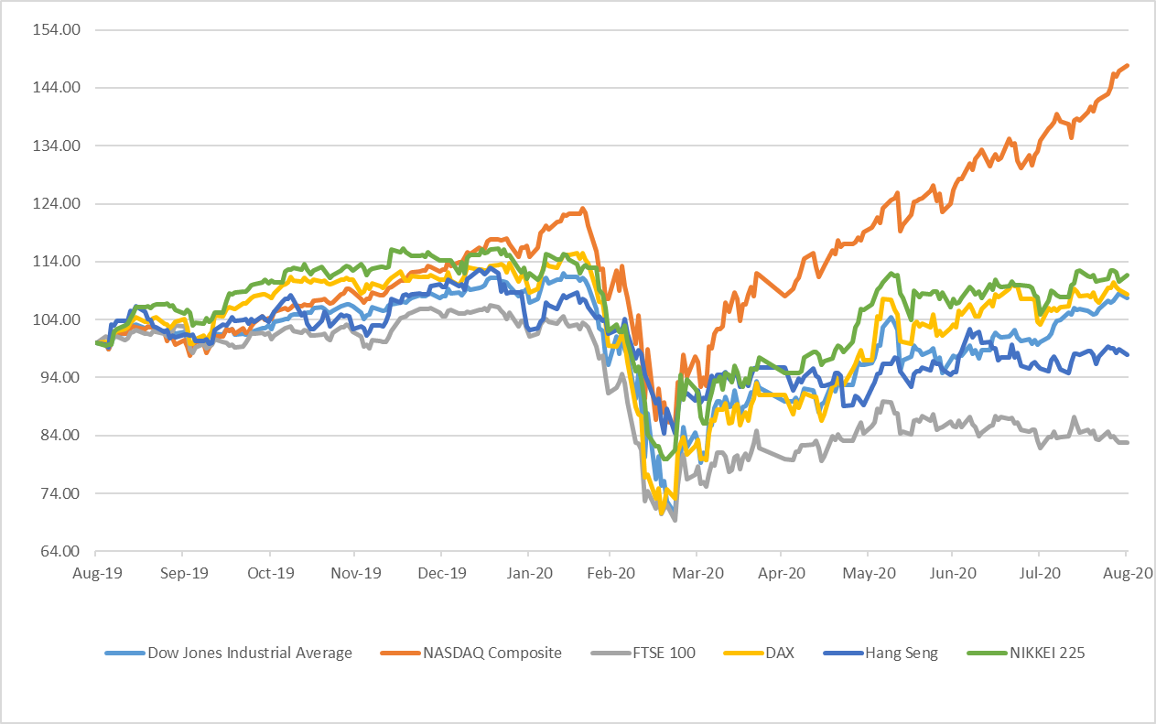

Note: All indices have been normalised to 100 on 31 August 2019.

Source: Bloomberg

Figure 2: Stock Market Trends in Selected Emerging Markets
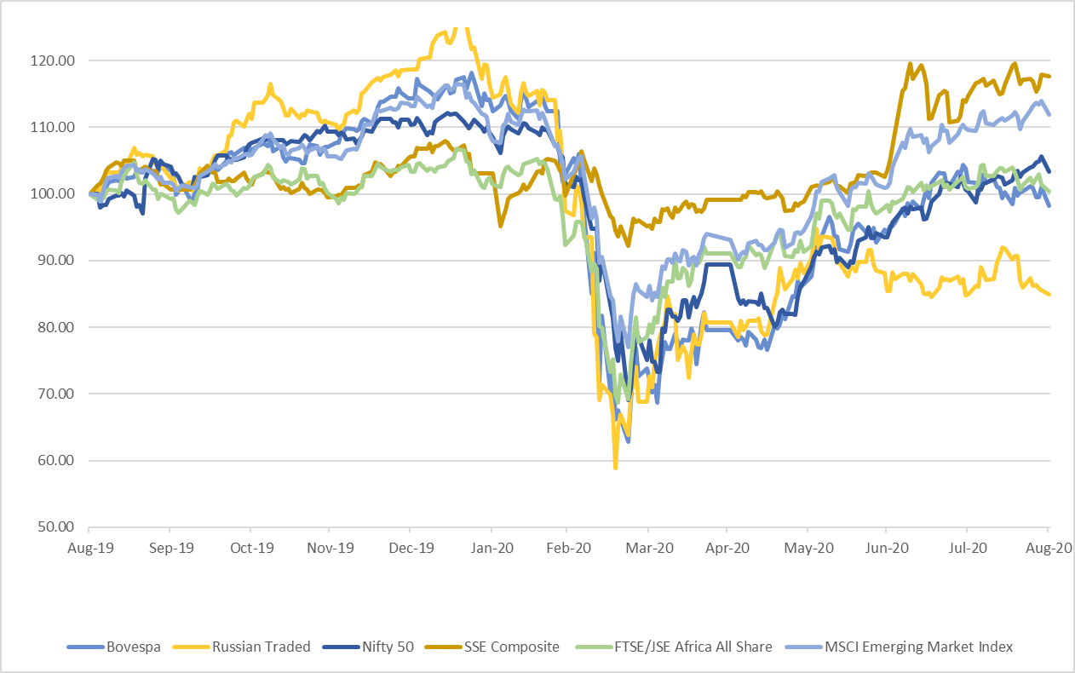

Note: All indices have been normalised to 100 on 31 August 2019.

Source: Bloomberg

BOND Market (Figures 3 - 4)
- Among the countries analysed for bond yield, 10-year bond yield showed a positive change for most developed and developing economies (Chart 3 & 4) except for Germany and Russia in August 2020.

Figure 3: Movement of 10-year Government Bond Yields in Developed Nations

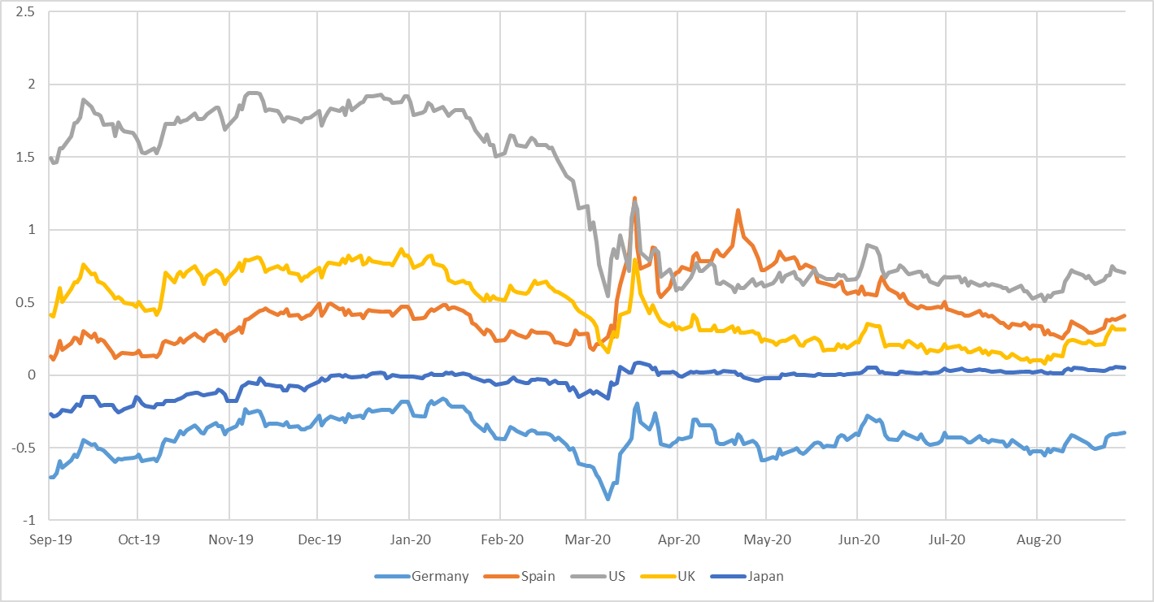

Source: Bloomberg

Figure 4: Movement of 10-year Government Bond Yields in BRIC Nations

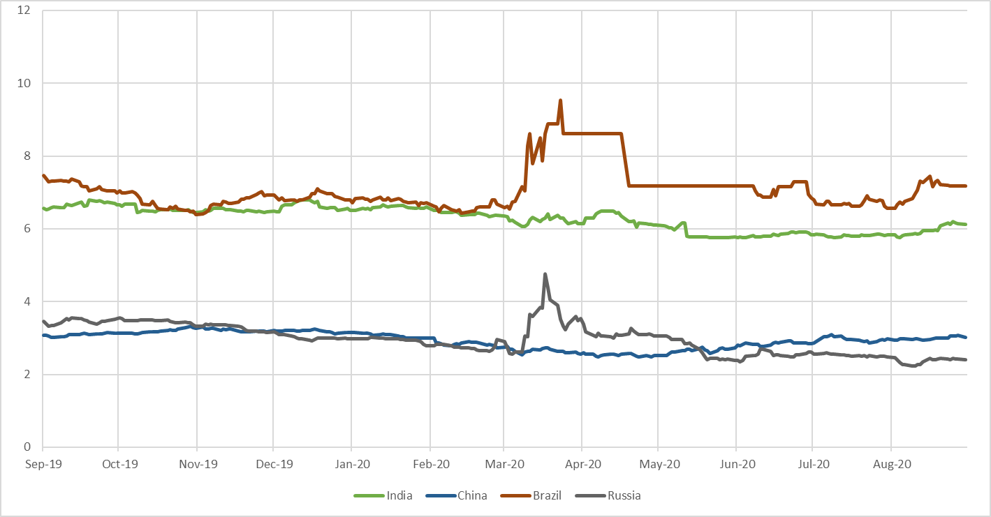

Source: Bloomberg

Fund Mobilisation by Issuance of Equity and Bonds (Table A2) –
- There was a 12.7 per cent decrease in the fund mobilization at the selected analyzed exchanges world-wide during July 2020 (at 4,47,549 million USD) against previous month (at 5,12,761 million USD). Only 11.6 per cent of the total fund mobilization in July 2020 was in equity and remaining was in debt.
- As per the data available on World Federation of Exchanges (WFE), highest amount mobilized through equities and bonds in July 2020 was at LSE Group (97,159 million USD) followed by NSE (57,176 million USD) and BME Spanish Exchanges (50,227 million USD).
- In July 2020, at LSE Group, 3,182 million USD were raised through equity and the remaining amount was raised through bonds whereas at NSE 534 million USD were raised through equity and the remaining amount was raised through bonds. At BME Spanish Exchanges 1,868 million USD were mobilized though bonds.
- Maximum fund mobilization through equities in July 2020 was at Shanghai Stock Exchange (20,076 million USD) followed by Hong Kong Exchanges and Clearing (10,582 million USD).

Market Capitalisation of Major Exchanges (Table A3) –

- Most of the analysed markets including developed markets, reflected an increase in market capitalization in the month of August 2020 as compared to previous month.

- Among the developed markets highest increase in market capitalization was observed for USA (8.4 per cent) followed by Japan (7.6 per cent) and Australia (6.4 per cent) in August 2020 as compared to previous month. For France, Germany and UK change in market capitalization was 4.6, 5.6 and 3.0 per cent, respectively.

- Among BRICS nations the highest increase was observed for India (6.0 per cent) followed by China (4.8 per cent), while a decrease in market capitalization was observed for Brazil (7.2 per cent) and South Africa (0.2 per cent). For Russia, change in market capitalization was 2.4 per cent over the previous month.

Derivatives (Figures 5-6, Table A4–A8) –

- During July 2020 the highest number of Single Stock Futures contracts traded was at Borsa Istanbul (11,42,61,423) followed by Korea Exchange (8,66,71,469). The highest number of single stock options were traded at Nasdaq – US (14,87,56,512) followed by B3 - Brasil Bolsa Balcão (12,13,40,382).
- In the same period, highest number of contracts of Index Futures were traded at B3 - Brasil Bolsa Balcão (27,31,60,103) followed by CME Group (10,14,07,591). Among the Stock Index Options, the highest number of contacts were traded at NSE (65,89,19,790) followed by Korea Exchange (4,75,40,766).
- Highest number of Currency Futures contracts were traded at B3 - Brasil Bolsa Balcão (8,25,49,163) followed by Moscow Exchange (6,12,01,541). The highest number of Currency Options were traded at NSE (6,83,56,988) followed by BSE India Limited (3,30,85,332).
- In July 2020, the highest number of Interest Rate (IR) Futures were traded at CME Group (6,79,46,890) followed by B3 - Brasil Bolsa Balcão (3,90,63,082) whereas the highest number of Interest Rate Options contracts were traded at CME Group (1,97,22,157) followed by Deutsche Boerse AG (31,33,435).
- The highest number of Commodity Futures contracts were traded at Dalian Commodity Exchange (20,11,01,345) followed by Shanghai Futures Exchange (19,14,12,365) in July 2020. Among the Commodity Options the highest number of contracts were traded at CME Group (1,07,38,005) followed by Dalian Commodity Exchange (69,81,367) during the same period.
- In August 2020, Pound and Rupee were most appreciating currency against dollar followed by Renminbi among the analysed currencies. The only depreciating currency was Real.

US Treasury Securities (Table A9)

- At the end of June 2020, Japan was the biggest foreign holder of US Treasury Securities with 17.9 per cent followed by China with 15.3 per cent. The total major foreign holding of US Treasury Securities was USD 7,038.9 billion. The holdings of US Treasury Securities by India slightly increased to 2.6 per cent at the end of June 2020 from 2.4 per cent a month earlier.

Figure 5: Movement of the Major Currencies against USD
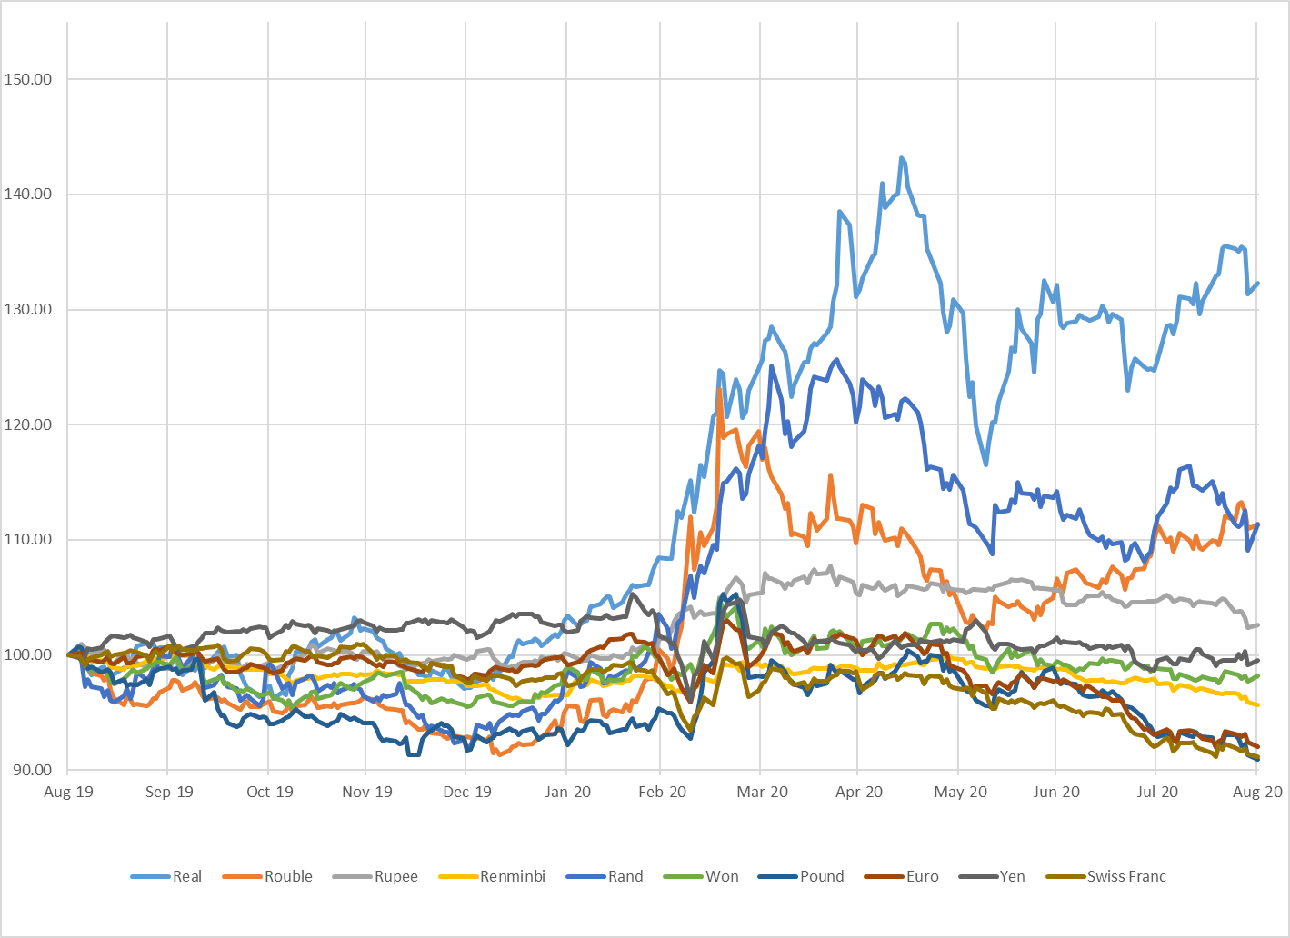
Note: All indices have been normalised to 100 on 31 August 2019.

Source: Bloomberg

Figure 6: Movement of the US Dollar Index and MSCI EM Currency Index

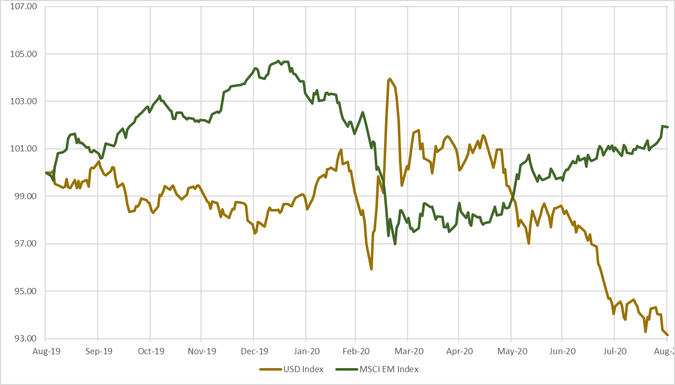
Note:
- All indices have been normalised to 100 on 31 July 2019.
- The U.S. Dollar Index is an index of the value of the United States dollar relative to a basket of foreign currencies. The Index goes up when the U.S. dollar gains value compared to other currencies. The index is maintained and published by Intercontinental Exchange. It is a weighted geometric mean of the dollar's value relative to following select currencies: Euro, Japanese yen, Pound sterling, Canadian dollar, Swedish krona, Swiss franc.
- The MSCI Emerging Markets (EM) Currency Index tracks the performance of twenty-five emerging-market currencies relative to the US Dollar.

Source: Bloomberg

Table A1: Performance of Stock Indices
Country | Name of the Index | Closing Value as on | Closing Value before |  |  |  | Monthly Volatility (Annualised) | P/E Ratio
 |  | 31-Aug-2020 | 1-Month | 3-Month | 6-Month | 1-Year
BRICS Nations
Brazil | BRAZIL IBOVESPA | 99369.2 | 102912.2 | 87402.6 | 104171.6 | 101134.6 | 31.1 | 66.9
Russia | RUSSIAN TRADED | 1617.5 | 1618.1 | 1678.0 | 1856.2 | 1904.7 | 26.3 | 8.1
India | Nifty 50 | 11387.5 | 11073.5 | 9580.3 | 11201.8 | 11023.3 | 16.6 | 32.3
India | S&P BSE SENSEX | 38628.3 | 37606.9 | 32424.1 | 38297.3 | 37332.8 | 16.6 | 27.3
China | SHANGHAI SE COMPOSITE | 3395.7 | 3310.0 | 2852.4 | 2880.3 | 2886.2 | 32.5 | 18.2
South Africa | FTSE/JSE AFRICA ALL SHR | 55476.1 | 55721.8 | 50483.0 | 51038.2 | 55259.6 | 17.5 | 19.5
Developed Markets
USA | NASDAQ COMPOSITE | 11775.5 | 10745.3 | 9489.9 | 8567.4 | 7962.9 | 24.8 | 66.5
USA | DOW JONES INDUS. AVG | 28430.1 | 26428.3 | 25383.1 | 25409.4 | 26403.3 | 13.6 | 24.5
France | CAC 40 | 4947.2 | 4783.7 | 4695.4 | 5309.9 | 5480.5 | 20.2 | 44.1
Germany | DAX | 12945.4 | 12313.4 | 11586.9 | 11890.4 | 11939.3 | 14.0 | 40.5
UK | FTSE 100 | 5963.6 | 5897.8 | 6076.6 | 6580.6 | 7207.2 | 20.3 | 92.7
Hong Kong | HANG SENG | 25177.1 | 24595.4 | 22961.5 | 26129.9 | 25724.7 | 19.4 | 13.1
South Korea | KOSPI | 2326.2 | 2249.4 | 2029.6 | 1987.0 | 1967.8 | 27.7 | 35.9
Japan | NIKKEI 225 | 23139.8 | 21710.0 | 21877.9 | 21143.0 | 20704.4 | 14.0 | 34.0
Singapore | STRAITS TIMES STI | 2532.5 | 2529.8 | 2510.8 | 3011.1 | 3106.5 | 23.2 | 19.2
Taiwan | TAIWAN TAIEX | 12591.5 | 12664.8 | 10942.2 | 11292.2 | 10618.1 | 26.5 | 20.8
Note: P/E Ratios as on the last trading day.
Source: Bloomberg, BSE and National Stock Exchange
Table A2: Fund Mobilisation by Issuance of Equity and Bond in Major Exchanges (USD million)
Month | Jun-20 |  |  | Jul-20
Exchange Name | Bond | Equity | Total | Bond | Equity | Total
B3 - Brasil Bolsa Balcão | 0 | 0 | 0 | 0 | 0 | 0
Nasdaq - US | 0 | 0 | 0 | 0 | 0 | 0
NYSE | 0 | 20,373 | 20,373 | 0 | 0 | 0
ASX Australian Securities Exchange | 72 | 6,261 | 6,333 | 0 | 2,688 | 2,688
Hong Kong Exchanges and Clearing | 27,714 | 12,021 | 39,734 | 16,773 | 10,582 | 27,355
Japan Exchange Group | 13,541 | 351 | 13,891 | 21,077 | 1,541 | 22,618
Korea Exchange | 72,586 | 0 | 72,586 | 46,787 | 0 | 46,787
National Stock Exchange of India | 60,497 | 8,731 | 69,228 | 56,643 | 534 | 57,176
Shanghai Stock Exchange | 0 | 12,197 | 12,197 | 0 | 20,076 | 20,076
Shenzhen Stock Exchange | 8,880 | 3,815 | 12,695 | 15,273 | 6,703 | 21,976
Singapore Exchange | 17,042 | 6,367 | 23,409 | 25,799 | 9 | 25,807
BME Spanish Exchanges | 63,697 | 370 | 64,066 | 48,359 | 1,868 | 50,227
Deutsche Boerse AG | 59,199 | 0 | 59,199 | 44,144 | 118 | 44,261
Euronext | 0 | 4,667 | 4,667 | 0 | 4,760 | 4,760
Johannesburg Stock Exchange | 3,691 | 797 | 4,488 | 4,423 | 1 | 4,424
LSE Group | 82,014 | 6,975 | 88,989 | 93,977 | 3,182 | 97,159
Moscow Exchange | 20,905 | 0 | 20,905 | 22,233 | 0 | 22,233
Grand Total | 4,29,837 | 82,924 | 5,12,761 | 3,95,489 | 52,060 | 4,47,549
Note: For Funds mobilised through issuance of bonds, data may differ due to different reporting rules & calculation methods. Fund mobilisation data for equities are (i) excluding investment funds and (ii) including Alternative and SME Markets except the following exceptions:
- Australian Securities Exchange: including investment funds
- BME: Including investment companies listed (open-end investment companies).
- Euronext: includes Belgium, England, France, Netherlands and Portugal
- Korea Exchange: including Kosdaq market data
- LSE Group: includes London Stock Exchange and BorsaItaliana
- Nasdaq Nordic Exchanges include Copenhagen, Helsinki, Iceland, Stockholm, Tallinn, Riga and Vilnius Stock Exchanges
- NSE India: including “Emerge” market data

NA = Not Available
Source: World Federation of Exchanges

Table A3: Domestic Market Capitalisation of Major Exchanges (USD million)
Markets | Country | Jul-20 | Aug-20 | % Change MoM
Developed Markets | USA | 34,997 | 37,934 | 8.4
 | UK | 2,756 | 2,839 | 3.0
 | Germany | 2,219 | 2,344 | 5.6
 | France | 577 | 603 | 4.6
 | Japan | 5,631 | 6,062 | 7.6
 | Singapore | 377 | 382 | 1.3
 | Hong Kong | 5,580 | 5,777 | 3.5
 | South Korea | 1,484 | 1,549 | 4.4
 | Australia | 1,309 | 1,393 | 6.4
BRICS | Brazil | 788 | 732 | -7.2
 | Russia | 566 | 580 | 2.4
 | India | 1,936 | 2,052 | 6.0
 | China | 9,446 | 9,898 | 4.8
 | South Africa | 330 | 329 | -0.2

Source: Bloomberg

Table A4: Stock Futures and Stock Options Traded in Major Exchanges

Notional Turnover in (USD million)
Exchange | Jul-20
 | Single Stock Futures |  |  | Single Stock Options
 | Number of | Notional | Open | Number of | Notional | Open
 | Contracts Traded | Turnover | Interest | Contracts Traded | Turnover | Interest
B3 - Brasil Bolsa Balcão | 2,91,52,200 | 101.07 | 1,23,50,200 | 12,13,40,382 | 67,787 | 3,75,27,523
Bolsa de Valores de Colombia | 6,342 | 9.72 | 7,559 | 0 | 0 | 0
Bolsa Mexicana de Valores | 100 | 0.03 | 600 | 10,000 | 1 | 10,000
Bolsa y Mercados Argentinos | 0 | 0 | 0 | 57,93,786 | 46 | 18,91,109
Cboe Global Markets | 0 | 0 | 0 | 10,43,18,766 | 0 | 20,58,19,371
Nasdaq - US | 0 | 0 | 0 | 14,87,56,512 | 0 | 0
MIAX Exchange Group | 0 | 0 | 0 | 3,86,84,870 | 9,63,803 | 0
ASX Australian Securities Exchange | 2,17,892 | 171.2 | 4,80,608 | 46,42,167 | 9,050 | 62,62,888
Hong Kong Exchanges and Clearing | 1,19,358 | 700.13 | 20,458 | 1,58,64,924 | 68,084 | 1,01,30,523
Japan Exchange Group | 0 | 0 | 0 | 9,792 | 0 | 40,541
Korea Exchange | 8,66,71,469 | 54931.38 | 50,66,886 | 89,841 | 0 | 26,871
National Stock Exchange of India | 2,27,10,216 | 210221.49 | 14,27,389 | 2,78,00,537 | 2,81,306 | 4,77,426
Singapore Exchange | 99,441 | 0 | 42,192 | 0 | 0 | 0
Taiwan Futures Exchange | 23,42,398 | 25870.52 | 1,93,206 | 11,169 | 126 | 4,708
Thailand Futures Exchange | 3,39,66,616 | 0 | 12,79,606 | 0 | 0 | 0
Athens Stock Exchange | 6,26,674 | 96.98 | 2,73,640 | 950 | 1 | 1,289
BME Spanish Exchanges | 1,59,411 | 53 | 12,46,576 | 13,87,754 | 1,675 | 83,36,690
Borsa Istanbul | 11,42,61,423 | 9921.67 | 57,60,197 | 2,69,661 | 31 | 2,06,744
Budapest Stock Exchange | 6,837 | 34.72 | 4,526 | 0 | 0 | 0
Deutsche Boerse AG | 31,83,127 | 15274.91 | 54,11,417 | 1,32,69,237 | 56,455 | 6,04,65,065
Euronext | 0 | 0 | 0 | 0 | 0 | 0
Moscow Exchange | 1,14,84,910 | 3095.45 | 11,32,684 | 85,217 | 23 | 1,22,276
Nasdaq Nordic and Baltics | 20,387 | 36.51 | 1,25,936 | 10,65,310 | 1,950 | 28,50,099
Tehran Stock Exchange | 0 | 0 | 0 | 4,17,062 | 47 | 0
Tel-Aviv Stock Exchange | 0 | 0 | 0 | 83,681 | 272 | 24,678
Warsaw Stock Exchange | 1,55,223 | 270.45 | 38,315 | 0 | 0 | 0
Dubai Gold and Commodities Exchange | 10,939 | 21.43 | 558 | 0 | 0 | 0
Grand Total | 30,51,94,963 | 3,20,811 | 3,48,62,553 | 48,39,01,618 | 14,50,656 | 33,41,97,801
NA: Not Available
Source: World Federation of Exchanges

Table A5: Index Futures and Index Options Traded in Major Exchanges
Notional Turnover in (USD million)
Exchange | Jul-20
 | Stock Index Futures |  |  | Stock Index Options
 | Number of  Contracts Traded | Notional  Turnover | Open  Interest | Number of  Contracts Traded | Notional  Turnover | Open  Interest
B3 - Brasil Bolsa Balcão | 27,31,60,103 | 11,16,356 | 13,21,062 | 53,03,523 | 35,230 | 5,17,176
Bolsa de Valores de Colombia | 3,605 | 3 | 4,941 | 0 | 0 | 0
Bolsa Mexicana de Valores | 33,314 | 553 | 23,375 | 491 | 8 | 256
Bolsa y Mercados Argentinos | 2,410 | 2 | 0 | 0 | 0 | 0
Cboe Global Markets | 0 | 0 | 0 | 2,90,57,332 | 0 | 2,13,92,595
Nasdaq - US | 0 | 0 | 0 | 3,05,946 | 0 | 0
MIAX Exchange Group | 0 | 0 | 0 | 0 | 0 | 0
Matba Rofex | 2,00,770 | 187 | 15,192 | 227 | 0 | 165
CME Group | 10,14,07,591 | 1,01,17,095 | 44,74,592 | 1,28,31,536 | 22,39,409 | 33,40,497
Cboe Futures Exchange | 31,56,652 | 0 | 2,70,667 | 0 | 0 | 0
ASX Australian Securities Exchange | 9,45,827 | 1,00,335 | 3,39,893 | 5,34,521 | 22,260 | 6,87,940
Hong Kong Exchanges and Clearing | 1,07,38,843 | 9,67,570 | 6,16,690 | 37,39,224 | 2,08,078 | 30,15,221
Japan Exchange Group | 2,58,83,572 | 9,93,284 | 18,91,014 | 77,708 | 0 | 66,825
Korea Exchange | 94,72,623 | 3,82,028 | 7,02,473 | 4,75,40,766 | 28,48,334 | 22,79,258
National Stock Exchange of India | 1,17,72,248 | 1,03,739 | 2,03,834 | 65,89,19,790 | 52,69,240 | 19,77,816
Singapore Exchange | 1,93,52,530 | 0 | 17,61,235 | 5,39,457 | 0 | 20,45,749
Taiwan Futures Exchange | 98,13,556 | 4,67,420 | 1,56,290 | 1,95,96,605 | 4,09,936 | 4,97,989
Thailand Futures Exchange | 33,68,225 | 0 | 3,03,843 | 96,571 | 0 | 46,179
Bursa Malaysia Derivatives | 3,17,803 | 5,879 | 29,314 | 1,140 | 0 | 363
China Financial Futures Exchange | 97,84,560 | 17,82,881 | 5,06,514 | 24,88,145 | 3,702 | 1,20,452
Athens Stock Exchange | 37,627 | 137 | 4,690 | 3,856 | 14 | 1,267
BME Spanish Exchanges | 5,60,970 | 40,060 | 1,09,092 | 1,03,800 | 839 | 6,40,072
Borsa Istanbul | 65,62,981 | 12,596 | 4,90,871 | 11,951 | 23 | 15,951
Budapest Stock Exchange | 30,952 | 37 | 17,239 | 0 | 0 | 0
Deutsche Boerse AG | 3,26,72,785 | 17,73,079 | 1,07,74,931 | 2,67,47,832 | 9,73,467 | 5,30,90,206
Euronext | 0 | 0 | 0 | 0 | 0 | 0
Moscow Exchange | 1,19,62,724 | 27,764 | 5,50,358 | 12,58,104 | 2,950 | 3,82,146
Nasdaq Nordic and Baltics | 30,76,968 | 60,345 | 4,64,227 | 4,26,364 | 8,432 | 5,83,637
Tel-Aviv Stock Exchange | 0 | 0 | 0 | 23,86,845 | 97,086 | 1,17,764
Warsaw Stock Exchange | 3,23,728 | 3,084 | 36,135 | 16,882 | 80 | 17,490
Grand Total | 53,46,42,967 | 1,79,54,433 | 2,50,68,472 | 81,19,88,616 | 1,21,19,087 | 9,08,37,014

NA: Not Available.

Source: World Federation of Exchanges

Table A6: Currency Futures and Options Traded in Major Exchanges
Notional Turnover in (USD million)
Exchange | Jul-20
 | Currency Futures |  |  | Currency Options
 | Number of  Contracts Traded | Notional  Turnover | Open  Interest | Number of  Contracts Traded | Notional  Turnover | Open  Interest
B3 - Brasil Bolsa Balcão | 8,25,49,163 | 10,87,080 | 45,30,799 | 5,50,675 | 391 | 6,86,908
Bolsa de Valores de Colombia | 21,559 | 999 | 10,673 | 6 | 0 | 26
Bolsa Mexicana de Valores | 1,39,049 | 1,415 | 4,65,572 | 2,000 | 20 | 7,800
Bolsa y Mercados Argentinos | 11,82,664 | 1,217 | 54,660 | 0 | 0 | 0
Matba Rofex | 89,69,892 | 9,639 | 36,94,739 | 1,212 | 0 | 0
CME Group | 1,58,08,118 | 14,89,334 | 17,02,126 | 8,11,361 | 95,451 | 6,47,929
BSE India Limited | 2,53,38,836 | 25,412 | 5,29,097 | 3,30,85,332 | 32,940 | 1,10,122
Hong Kong Exchanges and Clearing | 1,46,707 | 13,386 | 23,657 | 632 | 64 | 3,467
Korea Exchange | 91,56,677 | 92,052 | 7,69,069 | 0 | 0 | 0
National Stock Exchange of India | 5,51,60,793 | 57,310 | 24,67,614 | 6,83,56,988 | 68,614 | 27,50,855
Singapore Exchange | 16,69,400 | 0 | 1,12,013 | 280 | 0 | 355
Taiwan Futures Exchange | 33,866 | 957 | 2,947 | 3,144 | 86 | 594
Thailand Futures Exchange | 3,91,592 | 0 | 39,132 | 0 | 0 | 0
Borsa Istanbul | 37,87,499 | 3,910 | 15,86,416 | 17,623 | 17 | 11,791
Budapest Stock Exchange | 3,74,067 | 433 | 4,92,722 | 100 | 0 | 100
Moscow Exchange | 6,12,01,541 | 60,325 | 34,98,688 | 14,11,082 | 1,391 | 9,88,118
Tel-Aviv Stock Exchange | 0 | 0 | 0 | 10,66,421 | 10,804 | 4,71,605
Dubai Gold and Commodities Exchange | 9,02,840 | 6,162 | 1,38,358 | 46 | 0 | 0
Grand Total | 26,68,34,263 | 28,49,631 | 2,01,18,282 | 10,53,06,902 | 2,09,778 | 56,79,670

NA: Not Available

Source: World Federation of Exchanges

Table A7: Interest Rate Futures and Options Traded in Major Exchanges
Notional Turnover in (USD million)
Exchange | Jul-20
 | Interest Rate Futures |  |  | Interest Rate Options
 | Number of  Contracts Traded | Notional  Turnover | Open  Interest | Number of  Contracts Traded | Notional  Turnover | Open  Interest
B3 - Brasil Bolsa Balcão | 3,90,63,082 | 8,75,230 | 2,61,87,114 | 0 | 0 | 0
Bolsa de Valores de Colombia | 20,388 | 1,512 | 12,866 | 0 | 0 | 0
Bolsa Mexicana de Valores | 2,081 | 11 | 6,600 | 0 | 0 | 0
CME Group | 6,79,46,890 | 3,86,42,865 | 2,43,64,687 | 1,97,22,157 | 1,11,21,591 | 4,16,13,863
ASX Australian Securities Exchange | 75,64,643 | 10,74,367 | 36,06,739 | 2,890 | 206 | 540
BSE India Limited | 1,81,264 | 510 | 19,100 | 0 | 0 | 0
Japan Exchange Group | 4,47,517 | 0 | 81,340 | 7,26,586 | 0 | 6,19,842
Korea Exchange | 26,16,396 | 2,66,891 | 5,85,944 | 0 | 0 | 0
National Stock Exchange of India | 5,54,091 | 1,531 | 50,760 | 266 | 1 | 0
Singapore Exchange | 33,547 | 0 | 15,062 | 0 | 0 | 0
China Financial Futures Exchange | 25,99,290 | 3,98,811 | 1,63,686 | 0 | 0 | 0
Deutsche Boerse AG | 3,06,42,258 | 54,43,471 | 49,18,816 | 31,33,435 | 5,39,507 | 15,46,906
Moscow Exchange | 15,220 | 3 | 33,632 | 0 | 0 | 0
Nasdaq Nordic and Baltics | 89,139 | 10,154 | 10,33,399 | 3,34,996 | 38,161 | 0
Grand Total | 15,17,75,806 | 4,67,15,355 | 6,10,79,745 | 2,39,20,330 | 1,16,99,466 | 4,37,81,151

NA: Not Available

Source: World Federation of Exchanges

Table A8: Commodity Futures and Options Traded in Major Exchanges
Notional Turnover in (USD million)
Exchange | Jul-20
 | Commodities Futures |  |  | Commodities Options
 | Number of  Contracts Traded | Notional  Turnover | Open  Interest | Number of  Contracts Traded | Notional  Turnover | Open  Interest
B3 - Brasil Bolsa Balcão | 1,96,700 | 1,475 | 71,083 | 96,169 | 15 | 1,21,041
Matba Rofex | 1,18,781 | 870 | 53,333 | 6,984 | 3 | 14,004
CME Group | 7,03,08,160 | 36,99,009 | 1,40,81,296 | 1,07,38,005 | 5,03,867 | 1,08,14,496
ASX Australian Securities Exchange | 89,252 | 2,028 | 1,10,126 | 13,046 | 1,492 | 44,384
Hong Kong Exchanges and Clearing | 27,291 | 454 | 2,659 | 0 | 0 | 0
National Stock Exchange of India | 911 | 6 | 23 | 1,24,468 | 832 | 2,760
NZX Limited | 0 | 0 | 0 | 0 | 0 | 0
Singapore Exchange | 17,82,215 | 0 | 9,78,318 | 3,38,301 | 0 | 10,60,620
Taiwan Futures Exchange | 26,535 | 528 | 1,898 | 3,606 | 40 | 1,493
Thailand Futures Exchange | 6,93,790 | 0 | 38,348 | 0 | 0 | 0
Bursa Malaysia Derivatives | 11,56,841 | 17,222 | 1,85,654 | 8,250 | 0 | 21,900
Zhengzhou Commodity Exchange | 14,82,64,279 | 7,79,725 | 66,89,749 | 40,88,860 | 225 | 8,82,719
Dalian Commodity Exchange | 20,11,01,345 | 13,87,756 | 84,55,370 | 69,81,367 | 691 | 12,30,286
Multi Commodity Exchange of India | 2,08,32,044 | 1,14,008 | 1,44,727 | 1,57,530 | 2,812 | 7,882
Shanghai Futures Exchange | 19,14,12,365 | 21,57,922 | 71,77,129 | 0 | 0 | 0
Indian Commodity Exchange | NA | NA | NA | NA | NA | NA
Borsa Istanbul | 95,64,888 | 2,925 | 17,88,080 | 0 | 0 | 0
Deutsche Boerse AG | 4,16,985 | 17,593 | 19,98,449 | 16,24,229 | 6,025 | 14,82,076
Euronext | 12,56,384 | 16,135 | 4,69,614 | 1,30,375 | 1,592 | 2,90,055
LSE Group | 35 | 1 | 160 | 0 | 0 | 0
Moscow Exchange | 5,24,95,302 | 24,375 | 27,91,762 | 6,99,673 | 288 | 1,58,924
Dubai Gold and Commodities Exchange | 26,136 | 404 | 2,116 | 0 | 0 | 0
London Metal Exchange | 1,25,33,959 | 12,81,967 | 20,81,031 | 4,37,415 | 53,852 | 3,91,814
The Saint-Petersburg International Mercantile Exchange | 4,851 | 2,21,63,821 | 1,274 | 0 | 0 | 0
Grand Total | 71,23,09,049 | 3,16,68,225 | 4,71,22,199 | 2,54,48,278 | 5,71,734 | 1,65,24,454
NA: Not Available, data for Indian Commodity Exchange was not updated till the time of finalization of this report.

Source: World Federation of Exchanges

Table A9: Major Foreign Holders of US Treasury Securities (USD billion)
Country/ Month |  |  | 2019 |  |  |  |  | 2020
 | Aug | Sep | Oct | Nov | Dec | Jan | Feb | Mar | Apr | May | June
Japan | 1174.6 | 1146.2 | 1168.5 | 1160.6 | 1155.2 | 1211.8 | 1268.6 | 1272.6 | 1266.5 | 1260.4 | 1261.3
China, Mainland | 1103.5 | 1102.4 | 1101.5 | 1089.1 | 1069.9 | 1078.6 | 1092.3 | 1081.6 | 1072.8 | 1083.7 | 1074.4
United Kingdom | 434.6 | 412.7 | 412.7 | 400.5 | 392.1 | 450.3 | 477.1 | 469.7 | 429.2 | 445.8 | 445.6
Ireland | 272.3 | 274.1 | 285.4 | 289.7 | 281.9 | 271.7 | 282.8 | 271.6 | 301.3 | 324.2 | 330.4
Luxembourg | 244.2 | 252.3 | 263 | 261.9 | 254.6 | 255.2 | 260.8 | 246.1 | 265.5 | 262.7 | 267.6
Hong Kong | 252.2 | 242.5 | 243.6 | 249.7 | 249.7 | 253 | 268.4 | 256 | 259.4 | 269 | 266.4
Brazil | 313.4 | 303 | 298.5 | 293.3 | 281.8 | 283.3 | 285.9 | 264.4 | 259.5 | 264.4 | 264.1
Switzerland | 233 | 231.1 | 233.2 | 233.4 | 237.5 | 238.1 | 243.7 | 244.6 | 241.3 | 243.1 | 247.4
Cayman Islands | 248.8 | 250.9 | 236.8 | 234.2 | 238.2 | 225.1 | 228.2 | 209.4 | 213.1 | 216.7 | 222
Belgium | 215 | 215.5 | 205.6 | 202.4 | 207.4 | 206.5 | 218 | 206.1 | 210.2 | 212.1 | 218.7
Taiwan | 185.9 | 189 | 191.2 | 188.6 | 193.1 | 199.2 | 201.9 | 205 | 201.7 | 199.2 | 204.6
India | 162.2 | 160.7 | 161.4 | 159.2 | 162 | 164.3 | 177.5 | 156.5 | 157.4 | 169.9 | 182.7
Singapore | 145.5 | 141.8 | 138.8 | 150.6 | 147.9 | 160.7 | 165.4 | 151.5 | 146.1 | 142.1 | 150.5
France | 134 | 132.2 | 133.4 | 123 | 127.7 | 134 | 147.6 | 156 | 137.7 | 130.5 | 144.2
Canada | 157.8 | 153.4 | 157.1 | 155.2 | 143.3 | 157.9 | 148.3 | 131.5 | 136.3 | 129.9 | 127.5
Saudi Arabia | 183.8 | 181.5 | 178.9 | 179.7 | 179.8 | 182.9 | 184.4 | 159.1 | 125.3 | 123.5 | 124.9
Korea | 117.8 | 118.5 | 117.1 | 117.2 | 121.9 | 121.1 | 116.1 | 110.8 | 120 | 117.3 | 122.7
Norway | 101 | 99.2 | 100.3 | 96 | 90.1 | 97.7 | 103.3 | 98 | 93.2 | 87.6 | 89.5
Thailand | 94.1 | 93.5 | 95.2 | 91.2 | 90.5 | 96 | 91.3 | 81.8 | 80.5 | 85.8 | 85.5
Germany | 86.4 | 84.9 | 84 | 79.9 | 78.3 | 83.7 | 86 | 77.3 | 77.7 | 80.6 | 79.5
Netherlands | 63.9 | 62.1 | 61.7 | 62.2 | 65.1 | 67.7 | 70.9 | 69.1 | 66.2 | 67.9 | 69.4
Bermuda | 74.4 | 69.6 | 65.4 | 68.2 | 71.3 | 64.8 | 65.9 | 64.2 | 65.5 | 63.9 | 66.8
Israel | 42.9 | 46 | 45.4 | 45.6 | 43.1 | 45.6 | 45.1 | 41.1 | 43.2 | 46.8 | 47.6
Mexico | 53 | 51.5 | 49.1 | 49.1 | 45.3 | 45.8 | 47.5 | 40.9 | 45.4 | 47.4 | 47
Kuwait | 44.1 | 44.1 | 43.8 | 43 | 43.3 | 41.9 | 43.6 | 40.1 | 44.5 | 43.6 | 44.9
Philippines | 33.9 | 34 | 34.6 | 37.4 | 34.8 | 40.4 | 41.8 | 43.1 | 42.7 | 42.7 | 44.2
Spain | 43.6 | 43.1 | 45.6 | 44.4 | 50.4 | 43.9 | 46.2 | 43.8 | 44 | 47.3 | 44
Italy | 46.7 | 47.2 | 47.1 | 45.7 | 45.3 | 44.6 | 46.8 | 44.8 | 41.5 | 41.4 | 42.4
Australia | 41.8 | 39.6 | 45.4 | 44.6 | 41.8 | 45.1 | 43.7 | 46.3 | 44.8 | 43.5 | 41.9
Poland | 38.8 | 36.8 | 35.7 | 38.5 | 38.8 | 37.7 | 38.8 | 35.6 | 34.4 | 38 | 39.7
Sweden | 48.4 | 47.3 | 46.9 | 49.5 | 48.7 | 45 | 45.4 | 39.5 | 36.5 | 37.1 | 39.1
Iraq | 35.1 | 32.5 | 32.7 | 31 | 32.9 | 31.9 | 30.9 | 30.7 | 32.5 | 32.6 | 31.6
Vietnam | 26.7 | 28.8 | 29.2 | 29.9 | 30.5 | 30.3 | 31 | 30.7 | 29.6 | 30.3 | 30.3
All Other | 583.1 | 555.5 | 557.5 | 557.6 | 550.1 | 571.4 | 581.1 | 529.8 | 537.8 | 547.1 | 540.3
Grand Total | 7036.4 | 6923.5 | 6946.4 | 6902.1 | 6844.2 | 7027.3 | 7226.2 | 6949.5 | 6903.4 | 6978 | 7038.9
Of which:
For. Official | 4200.2 | 4150.9 | 4122.9 | 4101.2 | 4076.9 | 4169.9 | 4264.9 | 4117.9 | 4047.4 | 4105.9 | 4142.3
Treasury Bills | 295.2 | 290.8 | 288.1 | 273.6 | 268.6 | 294.8 | 306.1 | 283.2 | 331 | 355.7 | 382.5
T-Bonds & Notes | 3905 | 3860.1 | 3834.8 | 3827.6 | 3808.3 | 3875.1 | 3958.8 | 3834.6 | 3716.4 | 3750.2 | 3759.8
Note:
- Data available as on 14 September, 2020
- The data in this table are collected primarily from U.S.-based custodians and broker-dealers. Since U.S. securities held in overseas custody accounts may not be attributed to the actual owners, the data may not provide a precise accounting of individual country ownership of Treasury securities (see TIC FAQ #7 at: http://www.treasury.gov/resource-center/data-chart-center/tic/Pages/ticfaq1.aspx)
- Estimated foreign holdings of U.S. Treasury marketable and non-marketable bills, bonds, and notes reported under the Treasury International Capital (TIC) reporting system are based on monthly data on holdings of Treasury bonds and notes as reported on TIC Form SLT, Aggregate Holdings of Long-Term Securities by U.S. and Foreign Residents and on TIC Form BL2, Report of Customers' U.S. Dollar Liabilities to Foreign Residents.
Source: Department of the Treasury/Federal Reserve Board

HIGHLIGHTS OF DEVELOPMENTS IN INTERNATIONAL SECURITIES MARKET

1) SEC Proposes to Improve the Retail Investor Experience through Modernized Fund Shareholder Reports and Disclosures

The Securities and Exchange Commission (SEC) proposed comprehensive modifications to the mutual fund and exchange-traded fund disclosure framework to better serve the needs of retail investors.
The proposed framework would provide an alternative approach to keeping investors informed about their ongoing fund investments. Instead of receiving both prospectus updates and shareholder reports, existing investors would receive the streamlined shareholder report. In addition, the proposal would amend prospectus disclosure requirements to provide greater clarity and more consistent information regarding fees, expenses, and principal risks.

Source: https://www.sec.gov/news/press-release/2020-172

2)

3) IOSCO examines the evolution of liquidity provision in equity securities markets

The Board of the International Organization of Securities Commissions (IOSCO) published a report that explores how liquidity provision has evolved in equity securities markets in recent years.

The report, titled Liquidity Provision in the Secondary Markets for Equity Securities, identifies some of the key elements of market making programs that may help promote the provision of liquidity, strengthen investor confidence and foster fair and efficient markets.

Source: https://www.iosco.org/news/pdf/IOSCONEWS574.pdf

POLICY DEVELOPMENTS AT SEBI

- Procedural Guidelines for Proxy Advisors

Proxy advisory firms have mandated to disclose the methodologies and processes followed in the development of their research and in the corresponding recommendations to their clients. Proxy advisors have also been told to share their reports with clients and the company being reviewed. The provisions of this circular are applicable from September 01, 2020.

Source: SEBI/HO/IMD/DF1/CIR/P/2020/147 dated August 03, 2020

- Grievance Resolution between Listed Entities and Proxy Advisers

Proxy advisors, over the past few years, have played a key role in enabling shareholders to effectively participate in corporate governance decisions. Due to the inherent nature of the work, it is probable that proxy advisors and listed entities may have different views on any agenda item of the listed entity leading to grievances.

In order to facilitate resolution of such grievances of listed entities against SEBI registered proxy advisors, the listed entities now may approach SEBI which will examine the matter for non-compliance by proxy advisors with the provisions of the Code of Conduct under regulation 24(2) read with regulation 23(1) of the SEBI (Research Analyst) Regulations, 2014 and the procedural guidelines for proxy advisors issued vide SEBI circular no. SEBI/HO/IMD/DF1/CIR/P/2020/147 dated August 03, 2020.

Source: SEBI/HO/CFD/CMD1/CIR/P/2020/119 dated August 04, 2020

3. Administration and Supervision of Investment Advisers

It was decided to recognize a wholly owned subsidiary of the stock exchanges to administer and supervise Investment Advisers (IAs) registered with SEBI. Such recognition will be based on the eligibility of the parent entity for which the eligibility criteria is defined.

Source: SEBI/HO/IMD/DF1/CIR/P/2020/148 dated August 06, 2020

4. SEBI (International Financial Services Centres) Guidelines, 2015 - Amendment

International Financial Services Centre (IFSC) guidelines pertaining to eligibility criteria and shareholding limit for clearing corporations that wish to operate in such centres were amended. The decision, aimed at streamlining the operations of IFSC, has been taken after consultation with stakeholders.

Source: SEBI/HO/MRD2/DCAP/CIR/P/2020/149 dated August 07, 2020

5. Resources for Trustees of Mutual Funds

In addition to the existing provisions, some additional criteria were prescribed to provide administrative assistance to trustees of mutual funds in monitoring various activities of asset management companies . This will come into force from October 01, 2020.

Source: SEBI/HO/IMD/DF4/CIR/P/2020/0000000151 dated August 10, 2020

6. Investor grievances Redressal Mechanism – Handling of SCORES Complaints by Stock Exchanges and Standard Operating Procedure for Non-redressal of Grievances by Listed Companies

Procedure was defined for handling investor complaints by exchanges as well as standard operating procedure for actions to be taken against listed companies for failure to redress such grievances. This will come into force from September 01, 2020.

Source: SEBI/HO/OIAE/IGRD/CIR/P/2020/152 dated August 13, 2020

7. Corrigendum to Master Circular for Depositories dated October 25, 2019 on preservation of records

SEBI has issued a corrigendum to its circular issued in October 25, 2019, wherein it was mentioned that such records need to be maintained for five years. As per the new direction, depositories and depository participants need to preserve the records and documents for a minimum period of eight years.

Source: SEBI/HO/MRD2/DDAP/CIR/P/2020/153 dated August 18, 2020

8. Securities and Exchange Board of India (International Financial Services Centres) Guidelines, 2015- Amendments

Guidelines on reporting of statement of accounts for entities listing their debt securities in International Financial Services Centre (IFSC) were amendedin an effort to further streamlines the operations.

The entities listing their debt securities in IFSC were directed to prepare their statement of accounts in accordance with International Financial Reporting Standards (IFRS) or US GAAP (Generally Accepted Accounting Principles) or Indian accounting standards (IND-AS) or as applicable in the place of their incorporation, and incorporate it in the relevant disclosure documents to be filed with the exchange. In case an entity does not prepare its statement of accounts in accordance with IFRS/ US GAAP/ IND AS, a quantitative summary of significant differences between national accounting standards and IFRS shall be prepared by such entity and incorporated in the relevant disclosure documents to be filed with the exchange.

Source: SEBI/HO/MRD1/DSAP/CIR/P/2020/154 dated August 21, 2020

9. Securities and Exchange Board of India (International Financial Services Centres) Guidelines, 2015 - Amendments

Based on the consultations of the stakeholders, entities based in India or in a foreign jurisdiction were allowed to provide financial services in IFSC, subject to compliance with the applicable regulatory framework/guidelines for such financial services as specified by SEBI from time to time.

Source: SEBI/HO/MRD1/DSAP/CIR/P/2020/155 dated August 21, 2020

10. Procedural Guidelines for Proxy Advisors’ - Extension of implementation timeline

The timelines extended for implementation of procedural guidelines for proxy advisers to January 01, 2021. The guidelines issued by SEBI on August 03, 2020 were supposed to come into force from September 01, 2020.

Source: SEBI/HO/IMD/DF1/CIR/P/2020/157 dated August 27, 2020

11. Execution of Power of Attorney by the Client in Favour of the Stock Broker / Stock Broker and Depository Participant

Guidelines for execution of Power of Attorney (PoA) by client in favour of stock broker/stock broker and depository participant were issued on April 23, 2020. These guidelines were amended reiterating that that Power of Attorney is optional for opening of client account by stockbrokers or depository participants. Besides, the Power of Attorney should be used for transfer of securities held in the beneficial owner accounts of the client to stock exchanges deliveries/settlement obligations, for pledging or re-pledging of securities in favour of trading member or clearing member for the purpose of meeting margin requirements of the clients in connection with the trades executed by the clients on the stock exchange.

Source: SEBI/HO/MIRSD/DOP/CIR/P/2020/158 dated August 27, 2020

12. ‘Grievance Resolution between Listed Entities and Proxy Advisers’ – Extension of Timeline for Implementation

The timelines extended for implementation of ‘Grievance Resolution between listed entities and proxy advisers’ to January 01, 2021. Accordingly, implementation of grievance resolution between listed entities and proxy advisers was also extended to January 01, 2021.

Source: SEBI/HO/CFD/CMD1/CIR/P/2020/159 dated August 27, 2020

13. Temporary Relaxation in Processing of documents Pertaining to FPIs due to COVID-19

SEBI extended the relaxations provided to foreign portfolio investors and custodians for processing documents related to new investor registrations, if they belong to jurisdictions still under the lockdown.

Source: SEBI/HO/FPI&C/CIR/P/2020/162 dated August 31, 2020

14. Relaxation from Default Recognition due to Restructuring of Debt

SEBI extended the relaxation given for default recognition by credit rating agencies (CRAs) on account of restructuring of debt, till December 31, 2020 and also asked CRAs not to consider as default the restructuring of debt done solely due to COVID-19 related stress by lenders.

Source: SEBI/HO/MIRSD/CRADT/CIR/P/2020/160 dated August 31, 2020

REGULATORY ACTIONS TAKEN BY SEBI

- Vide order dated August 04, 2020, Top Class Capital Markets Pvt. Ltd. was directed to disgorge the illegal gains of Rs. 3,77,89,062/- (Three crore seventy seven lakh eighty nine thousand and sixty two only) made by it, along with interest at the rate of 12 per cent per annum from March 04, 2009 till the date of actual payment of disgorgement amount along with interest, within 45 days, and restrained it from accessing the securities market. Top Class Capital Markets Pvt. Ltd. was further prohibited from buying, selling or otherwise dealing in securities, directly or indirectly, or being associated with the securities market in any manner, whatsoever, for a period of one year.

- Vide order dated August 04, 2020, Chetan Yashwant Shukla was directed to cease and desist from acting as an investment advisor and cease to solicit or undertake such activity or any other activities in the securities market, directly or indirectly, in any matter whatsoever until further orders and not to access the securities market and buy, sell or otherwise deal in securities. He was further directed to not to alienate any assets, movable or immovable, and immediately withdraw and remove all advertisements, representations, literatures, brochures, materials, publications, documents, websites, etc. in relation to their investment advisory and or any other unregistered activity in the securities market.

- Vide order dated August 04, 2020, Fortunescript Services Private Limited and its directors were directed to cease and desist from acting as an investment advisor including the activity of acting and representing through any media (physical or digital) as an investment advisor, directly or indirectly, and cease to solicit or undertake such activity or any other activities in the securities market, directly or indirectly, and not to access the securities market and buy, sell or otherwise deal in securities in any matter whatsoever, until further orders, in the matter of Fortune Services Private Limited.

- Vide order dated August 04, 2020, Global Portfolio Management and its proprietor Imran Khan were directed to cease and desist from acting as an investment advisor including the activity of acting and representing through any media (physical or digital) as an investment advisor, directly or indirectly, and cease to solicit or undertake such activity or any other activities in the securities market, directly or indirectly and not to divert any funds collected from investors, kept in bank account(s) and/or in their custody until further orders, in the matter of Global Portfolio Management.

- Vide order dated August 12, 2020, National Steel & Agro Industries Ltd. and others were warned to be careful in all their future dealings in the securities market and ensure that the same are done strictly in accordance with law, in the matter of trading activities of certain entities in Castor Seeds at NCDEX.

- Vide order dated August 18, 2020, the penalty amount enhanced from Three lakh rupees (imposed through an Adjudication Order dated February 26, 2020) to Five lakh rupees on Ashok Kumar Damani for violation of Regulations 3(a), (b), (c), (d), 4(1) and 4(2)(a) of SEBI PFUTP Regulations, in the matter of illiquid stock options at BSE.

- Vide order dated August 24, 2020, the certificate of registration of Corporate Strategic Allianz Ltd, was suspended with immediate effect as a merchant banker, for non-compliance with the conditions of registration as mandated under Regulation 9A(1)(e) read with Regulation 6(gg) of the Merchant Bankers Regulations and Section 12(1) of the SEBI Act. It further added that such suspension shall continue till the end of one year from the date of actual receipt by SEBI of the disgorgement amount along with due interest, in full, which the Corporate Strategic Allianz Ltd is liable to pay as per the direction of SEBI order dated August 12, 2016.

- Vide order dated August 31, 2020, Chetan Dogra and Chetan Dogra HUF was restrained from accessing the securities market and further prohibited them from buying, selling or otherwise dealing in securities, directly or indirectly, or being associated with the securities market in any manner, for a period of one year and also restrained Shraddha Entertainment Private Limited for a period of six years from the date of this order, in the matter of Urja Global Limited and Sampada Chemicals Limited.

- Vide order dated August 31, 2020, Suryamangal Media Entertainment Limited and others were debarred from accessing the securities market and further prohibited from buying, selling or otherwise dealing in securities, directly or indirectly in any manner, for 1 year, Madhuben Babulal Modi and others for 3 months, Omprakash Agarwal HUF and others for 6 months, in the matter of Kelvin Fincap Limited.

- Vide order dated August 31, 2020, Kelvin Fincap Limited and others were directed not to access the securities market, directly or indirectly, by issuing prospectus, offer document or advertisement soliciting money from the public for a period of 3 years and are further restrained and prohibited them from buying, selling or otherwise dealing in the securities market, directly or indirectly in whatsoever manner, for a period of 7 years. SEBI also restrained Surekaben K Shah and others from holding post of director, any managerial position or associating themselves in any capacity with any listed public company and any public company which intends to raise money from the public, or any intermediary registered with SEBI for a period of 3 years, in the matter of Kelvin Fincap Limited.

- Vide order dated August 31, 2020, a penalty of Rs. 5,00,000/-(Rupees Five Lakh only) imposed upon Hongkong and Shanghai Banking Corporation Limited, designated depository participant, in the matter of Pathway Finance Societe A Responsabilite Limited, for violation of clause 5.1.4 of operational guidelines of DDP’s issued vide SEBI Circular No. CIR/IMD/FIIC/02/2014 dated January 08, 2014.

- Vide order dated August 31, 2020, a penalty of Rs.8,00,000/-(Rupees Eight lakhs only) imposed on Tanuj Khandelwal in the matter of Malabar Trading Company Ltd, for violation of the provisions of Regulations 3 (a), (b), (c), (d), 4 (1), (2) (a) and (e) of SEBI (Prohibition of Fraudulent and Unfair Trade Practices relating to the Securities Market) Regulations, 2003. (“PFUTP Regulations”)

- Vide order dated August 31, 2020, a penalty of Rs.1,00,000/-(Rupees One lakh only) imposed on Maxgain Advisory Pvt. Ltd. in the matter of SRK Industries Limited, for the violation of provisions of the SEBI (Prohibition of Insider Trading) Regulations, 2015 (“ PIT Regulations, 1992”), read with regulation 12 of PIT Regulations 2015.

- Vide order dated August 31, 2020, a total penalty of Rs.2,00,000/- (Rupees Two Lakhs only) imposed on Kenrich Commodities Private Limited in the matter of inspection of Kenrich Commodities Private Limited, for the violation of various provisions of SEBI circular No. SMD/SED/CIR/93/23321 dated November 18, 1993, SEBI Circular No. SEBI/HO/MIRSD/MIRSD2/CIR/P/2016/95 dated September 26, 2016, SEBI Circular No. SEBI/MIRSD/SE/Cir-19/2009 dated December 03, 2009, SEBI Circular No. SEBI/HO/CDMRD/DRMP/ CIR/P/2016/80 dated September 07, 2016, SEBI Circular No. CIR/MIRSD/66/2016 dated July 21, 2016 read with SEBI Circular No. CIR/MIRSD/120/2016 dated November 10, 2016; SEBI Circular No. CIR/MIRSD/15/2011 dated August 02, 2011.

- Vide order dated August 31, 2020, a penalty of Rs.1,00,000/- (Rupees One lakh only) imposed on Island Media and Entertainment Pvt. Ltd. in the matter of SRK Industries Limited, for the violation of provisions of the PIT Regulations 1992, read with regulation 12 of PIT Regulations 2015.

- Vide order dated August 31, 2020, a penalty of Rs.1,00,000/- (Rupees One Lakh only) imposed on Geeta Narayanan in the matter of SRK Industries Limited, for the violation of provisions of the PIT Regulations 1992, read with regulation 12 of PIT Regulations 2015.

- Vide order dated August 31, 2020, a penalty of Rs. 1,00,000/- (Rupees One Lakh only) imposed on Birendra Kumar Jain in the matter of SRK Industries Limited, for the violation regulation 13 (2A) of the PIT Regulations 1992.

- Vide order dated August 31, 2020, a penalty of Rs. 15,00,000/- (Rupees Fifteen Lakhs only) imposed on Renish Hareshbhai Bhuvain in the matter of circulation of UPSI through WhatsApp messages with respect to HDFC Bank Limited, for violation of Sections 12A(e) of the SEBI Act, 1992 and Regulation 3(1) of PIT Regulations 2015.

- Vide order dated August 31, 2020, a penalty of Rs.10,00,000/- (Rupees Ten Lakh only) imposed on Amtek Auto Limited for violations of provision of regulations 51(1), 51(2) r/w Part B of schedule II (Clause A1, A4, A9), 52 (4), 52 (5), 54 (2), 57 (1) and 60 (2) of SEBI (Listing Obligations and Disclosure Requirement) Regulations, 2015.

- Vide order dated August 31, 2020, a total penalty of Rs.46,25,000/-(Rupees Forty Six Lakhs and Twenty Five Thousand only ) imposed on Pankaj J. Shah (HUF), and 36 others for the violation of Section 12 A (a), (b) and (c) of the SEBI Act, 1992 and regulations 3(a), (b), (c) and (d) and 4 (1) of the PFUTP Regulations 2003, and Section 2 (i)(a) of Securities Contracts (Regulation) Act, 1956 (“SCRA”) r/w, sections 13, 16 and 18 of the SCRA in the matter of trading activities of Pankaj J Shah HUF and connected entities in the scrips of L and T Finance Holdings Ltd, Tree House Education Ltd and Future Ventures India Ltd.

- Vide order dated August 31, 2020, a penalty of Rs. 3,00,000/-(Rupees Three Lakh only) imposed on Marconi James Macwan and others in the matter of Steel Exchange India Ltd., for the violation of section 11 C (3) of the SEBI Act.

- Vide order dated August 05, 2020, a total penalty of Rs. 80,00,000/-(Rupees Eighty Lakhs Only) imposed on Dr. V. K. Sukumaran and others for the violation of Section 16 of SCRA read with Sections 2(i), 13 and 18 of SCRA and SEBI Notification G.S.R. 219 (E) dated March 2, 2000, in the matter of VKS Project Limited.

- Vide order dated August 10, 2020, a penalty of Rs. 5,00,000/-(Rupees Five Lakhs Only) imposed on Bhawani Ferrous Private Limited for the violation of the provisions of Regulations 3 (a), (b), (c), (d), and 4(1), 4(2), (a) of SEBI (Prohibition of Fraudulent and Unfair Trade Practices relating to the Securities Market) Regulations, 2003 (SEBI PFUTP Regulations), in the matter of its dealing in illiquid stock options at BSE.

- Vide order dated August 11, 2020, a penalty of Rs. 2,00,000/-(Rupees Two Lakh only) imposed on Siddarth Businesses Limited for the violation of sections 11C(2) and 11C(3) of the SEBI Act, in the matter of Siddarth Businesses Limited (currently known as Shivamshree Businesses Limited).

- Vide order dated August 11, 2020, a total penalty of Rs. 8,00,000/-(Rupees Eight Lakh only) imposed on India Advantage Securities Pvt. Ltd. for the violation of clause 3.2 of SEBI circular SEBI/HO/MIRSD/MIRSD2/CIR/P/2016/95 dated September 26, 2016, in the matter of India Advantage Securities Pvt. Ltd.

- Vide order dated August 11, 2020, a penalty of Rs. 6,55,00,000/-(Rupees Six crores and Fifty-Five Lakhs Only) imposed on 81 entities including Dhyana Finstock Ltd for misusing issuance of stocks on preferential basis and hence causing the violation of Section 12A (a), (b) & (c) of SEBI Act, 1992 r/w Regulation 3(a), (b), (c), (d) and Regulation 4(1) of SEBI PFUTP Regulations and Regulation 77(1) of SEBI (Issue of Capital and Disclosure Requirements) Regulations, 2009, in the matter of Dhyana Finstock Ltd.

- Vide order dated August 11, 2020, a penalty of Rs. 25,00,000/-(Rupees Twenty Five Lakh only) imposed on the Yochana Vyapaar Private Limited for the violation of the provisions of Regulations 3(a), (b), (c), (d) and 4(1), 4(2) (a) of SEBI PFUTP Regulations, in the matter of dealing in illiquid stock options at BSE.

- Vide order dated August 14, 2020, a penalty of Rs. 10,00,000/-(Rupees Ten Lakh) imposed on State Bank of India for failing to reduce its stake in UTI Mutual Fund below 10 per cent within the stipulated time, causing the violation of Regulation 7B of SEBI (Mutual Fund) Regulations 1996.

- Vide order dated August 14, 2020, a penalty of Rs. 10,00,000/-(Rupees Ten Lakh) imposed on Life Insurance Corporation of India for failing to reduce its stake in UTI Mutual Fund below 10 per cent within the stipulated time, causing the violation of Regulation 7B of SEBI (Mutual Fund) Regulations 1996.

- Vide order dated August 14, 2020, a penalty of Rs. 10,00,000/-(Rupees Ten Lakh) imposed on Bank of Baroda for failing to reduce its stake in UTI Mutual Fund below 10 per cent within the stipulated time, causing the violation of Regulation 7B of SEBI (Mutual Fund) Regulations 1996.

- Vide order dated August 14, 2020, a total penalty of Rs. 5,00,000/- (Rupees Five Lakh only) imposed on C D Integrated Services Private Limited for the violation of provisions of Clause 7 of Annexure of SEBI circular SEBI/HO/MIRSD/MIRSD2/CIR/P/2016/95 dated September 26, 2016.

- Vide order dated August 19, 2020, a penalty of Rs. 14,10,000/-(Rupees Fourteen Lakhs Ten Thousand only) imposed on Balaji Infrasolution Pvt. Ltd. for the violation of the provisions of Regulations 3 (a), (b), (c), (d) and 4 (1), 4 (2), (a) of SEBI (Prohibition of Fraudulent and Unfair Trade Practices relating to the Securities Market) Regulations, 2003 (SEBI PFUTP Regulations), in the matter of dealing in illiquid stock options at BSE.

- Vide order dated August 20, 2020, a penalty of Rs. 2,00,000/-(Rupees Two Lacs only) imposed on Orissa Minerals Development Co. Ltd., Dr. Satish Chandra and Ms. Sucharita Das for violation of Clause 2.1 of Code of Corporate Disclosure Practice for Prevention of Insider Trading contained in Schedule II to Regulation 12 (2) of the SEBI (Prohibition of Insider Trading) Regulations, 1992 and also violation of Clause 36 of Listing Agreement read with Section 21 of SCRA, in the matter of Orissa Minerals Development Co. Ltd.

- Vide order dated August 21, 2020, a penalty of Rs. 2,00,000/- (Two lakhs Only) imposed on Raj Kumar for the violation of regulation 29(1) r/w regulation 29 (3) of SEBI (Substantial Acquisition of Shares and Takeovers) Regulations, 2011 (SAST Regulations), in the matter of Maximaa Systems Private Ltd.

- Vide order dated August 21, 2020, a total penalty of Rs. 22,39,00,000/- (Twenty two crore and thirty nine lakh only) imposed on Ravikumar Distilleries Ltd (RKDL) and 31 others for siphoning of funds to the tune of Rs. 33.83 crore from the IPO proceeds of the RKDL through series of circuitous transfers involving creating artificial liability in the books of RKDL, causing the violation of various regulations including Section 12A (a), (b) and (c) of SEBI Act, 1992, Regulations 3 (a), (b), (c), (d), 4 (1),4 (2), (f) and (k) of SEBI (PFUTP) Regulations 2003, Regulations 39, 57(1), 60(4) (a), 60 (7)(a), 64(1) and 8(2)(b), (e) and (f) of SEBI (Issue of Capital and Disclosure Requirements) Regulations, 2009, and Clauses 1, 2, 3, 4, 6, 7 and 21 of the Code of Conduct for Merchant Bankers specified under Schedule III in the SEBI (Merchant Bankers) Regulations, 1992, in the matter of Ravi Kumar Distilleries Ltd.

- Vide order dated August 18, 2020, a penalty of Rs. 5,00,000/- (Five lakhs Only) imposed on Sasidhar V for deliberate tampering of the Date and Time Stamping Machine (DTSM) to give favour to certain investors and hence violating provisions of Regulations 3(a) and 4(1) of PFUTP Regulations, 2003.

- Vide order dated August 24, 2020, a penalty of Rs. 5,00,000/- (Rupees Five Lakh Only) imposed on MCS Share Transfer Agent Limited in the matter of Inspection/Audit of Books for the violation of the provisions of Regulation 18(1) read with Regulation 21 of SEBI (Registrar to an Issuer and Share Transfer Agent) Regulations, 1993 (“SEBI RTI and STA Regulations”) and Clause 18 of the Code of Conduct for the Registrars to an Issue and Share Transfer Agent prescribed in Schedule III under Regulation 13 of the SEBI (RTI and STA) Regulations.

- Vide order dated August 25, 2020, a penalty of Rs.10,00,000/- (Rupees Ten Lakh only) imposed on T.A.N. Murti, head of investor relations of Satyam Computer Services Limited, for the violation of Regulation 3(i) of the SEBI (Prohibition of Insider Trading) Regulations, 1992 (“PIT Regulations, 1992”) read with 12A (d) and (e) of the SEBI Act 1992, in the matter of Satyam Computer Services Ltd.

- Vide order dated August 25, 2020, a penalty of Rs. 50,00,000/- (Rupees Fifty Lakh Only) imposed on National Stock Exchange of India Limited for the violation of regulation 27 (4) of the Securities Contracts (Regulation) (Stock Exchanges and Clearing Corporations) Regulations, 2012, in the matter of National Stock Exchange of India Limited.

- Vide order dated August 26, 2020, a total penalty of Rs.7,00,000/- (Rupees Seven Lakh Only) imposed on Jayarama Shetty Mundaje and others in the matter of Suprajit Engineering Ltd. for the violation of Regulation 7(2)(a) of of SEBI (Prohibition of Insider Trading) Regulations, 2015 (PIT Regulations, 2015), Clause 6 of Minimum Standard of Code of Conduct contained in Schedule B read with Regulation 9(1) of PIT Regulations, 2015 read Clauses 5.3 & 5.4 of Code of Conduct dated May 29, 2015 of Suprajit Engineering Ltd. read with Regulation 9(1) of PIT Regulations 2015,

- Vide order dated August 26, 2020, a penalty of Rs. 2,00,000/- (Rupees Two Lakh Only) imposed on Anoop Kumar Garg for the violations of the provisions of Regulations 13(3) read with 13(5) of PIT Regulations, 1992 and Regulations 13(4) read with 13(5) of PIT Regulations, 1992, in the matter of Centron Industrial Alliance Limited.

- Vide order dated August 26, 2020, a penalty of Rs. 1,00,000/- (Rupees One Lakh only) imposed upon Soarabh Rakesh Jain for the violation of PIT Regulations 1992 read with regulation 12 of PIT Regulations 2015, in the matter of SRK Industries Limited.

- Vide order dated August 26, 2020, a penalty of Rs. 1,00,000/- (Rupees One Lakh only) imposed upon Rakeshchand M Jain for the violation of PIT Regulations 1992 read with regulation 12 of PIT Regulations 2015, in the matter of SRK Industries Limited.

- Vide order dated August 27, 2020, a penalty of Rs. 1,00,000/- (Rupees One Lakh only) imposed on Sital Leasing and Finance Limited for violation of Regulation 7(2)(b) of PIT Regulations 2015, in the matter of Sital Leasing and Finance Limited.

- Vide order dated August 27, 2020, a penalty of Rs. 5,00,000/-(Rupees Five Lakh only) imposed on H Bhavesh Securities and Commodities Private Limited for the violation of the provisions of Regulations 3(a), (b), (c), (d) and Regulations 4(1), 4 (2) (a) of SEBI (Prohibition of Fraudulent and Unfair Trade Practices relating to the Securities Market) Regulations, 2003 (“PFUTP Regulations”) stand established, in the matters of Spectacle Infotek Limited, Goldstone Technologies Limited, Gemstone Investments Limited, LGS Global Limited and Well Pack Papers and Containers Limited.

- Vide order dated August 27, 2020, a total penalty of Rs. 8,00,000/- (Rupees Eight Lakh only) imposed on Harsh Dugar for the violation of the Federal Bank Code of Conduct prescribed under Regulation 9 (1) of PIT Regulations read with Clause 6 of Schedule B of PIT Regulations, in the matter of Federal Bank Limited.

- Vide order dated August 27, 2020, a total penalty of Rs. 15,00,000/- (Rupees Fifteen Lakhs Only) imposed on Nikki Global Finance Limited and others for the violation of Regulation 13(6) of PIT Regulations, 1992 read with Regulation 12 of PIT Regulations 2015, Regulation 13(1) & 13(3) read with Regulation 13(5) of PIT Regulations, 1992 and Regulations 29(1) and 29(2) read with 29(3) of the SEBI (Substantial Acquisition of Shares and Takeovers) Regulations, 2011(“SAST Regulations”), in the matter of Nikki Global Finance Limited.

- Vide order dated August 27, 2020, a penalty of Rs. 1,00,000/- (Rupees One Lakh only) imposed on Ashok Kumar Kayan, a stock broker, for violation of the provisions of Section 23D of SCRA and SEBI Circular No. MRD/DoP/SE/Cir-11/2008 dated April 17, 2008, in the matter of Nikki Global Finance Limited.

- Vide order dated August 27, 2020, a penalty of Rs. 1,00,000/- (Rupees One Lakh only) imposed upon Kanchan Bihani for the violation of Regulation 29 (1) read with 29 (3) of SAST Regulations, in the matter of Sanjivani Paranteral Ltd.

- Vide order dated August 27, 2020, a total penalty of Rs.70,00,000/-(Seventy Lakhs only) imposed on Kapila Vaghela and others for the violation of Section 12A (a), (b) and (c) and of Regulations 3 (a), (b), (c) and (d), as well as 4 (1), (2) (a),(e) and (g) of the PFUTP Regulations, in the matter of Vani Commercials Ltd.

- Vide order dated August 28, 2020, a total penalty of Rs.15,00,000/-(Rupees Fifteen Lakh only) imposed on Electrotherm (India) Limited and others for the violation of Clause 41(I), 49(V) and clause 50 of the erstwhile Equity Listing Agreement read with section 21 of Securities Contracts (Regulation) Act, 1957 (“SCRA”) and Regulations 4(1)(a), 4 (1) (b), 4 (2)(f), 33 (1) and 48 of LODR, in the matter of Electrotherm India Limited.

- Vide order dated August 28, 2020, a total penalty of Rs.5,00,000/-(Rupees Five Lakh only) imposed on GRM Securities Pvt. Ltd. for the violation of clauses A(1), A(2) and A(4) of Code of Conduct specified in Schedule II read with regulation 9(f) and regulation 26 (xi), (xv), (xvi) and (xx) of Brokers Regulations, and regulations 3, 4(1) and 4 (2)(a) of PFUTP Regulations stands established, in the matter of inspection of GRM Securities Pvt. Ltd.

- Vide order dated August 28, 2020, a total penalty of Rs.19,00,000/- (Nineteen Lakh only) imposed on Melicent Sales Agencies Private Ltd and others for the violation of Regulations 29 (1) read with 29 (3) of the SAST Regulations, Regulations 3 (a), (b), (c) and (d) as well as Regulation 4 (1) and (2) (a) and (e) of the PFUTP Regulations, in the matter of Ramchandra Leasing and Finance Ltd.

- Vide order dated August 28, 2020, a penalty of Rs.3,00,000/-(Rupees Three lakh) imposed on Vipin Sharma for violation of the provisions of section 12A(a), (b), (c) of the SEBI Act read with Regulations 3(a), (b), (c), (d) and 4(1) of the PFUTP Regulations, in the matter of Chromatic India Ltd. SEBI, vide an order dated August 28, 20202, imposed a penalty of Rs.5,00,000/- (Rupees Five Lakh only) on Sanjeev Kapur for the violation of provisions of Section 12(1) of the SEBI Act read with regulation 11(1) of the Stock Brokers and Sub Brokers Regulations, 1992, Regulations 3(a), 4(1), 4(2)(a) & (p)of PFUTP Regulations read with and Clause A(1) & A(2) of the Code of conduct for sub brokers as stipulated in schedule II read with Regulation 15(1)(b) and Regulations 26(xi), (xv) & (xvi) of SEBI (Stock Brokers and Sub Brokers) Regulations, 1992 (“SBSB Regulations”), in the matter of Sanjeev Kapur.

- Vide order dated August 24, 2020, SEBI directed that a sum of Rs. 2,60,93,085.85/- shall be impounded jointly and severally, from Dhiren Mahendrakumar Shah HUF, Amee Dhiren Shah and Affluence Fincon Service (P) Ltd, being the notional gains made on account of trades carried out by them in the respective trading accounts for trading in the scrip of Infibeam Avenues Ltd., while being in the possession of Unpublished Price Sensitive Information (UPSI). It was further directed that a sum of ₹97,36,444.34/- shall be impounded from Infinium Motors (Gujarat) Pvt. Ltd (“IMGPL”) being the notional gain made on account of trades carried out in the trading accounts of IMGPL, in the matter of Infibeam Avenues Ltd.

Disclaimer: The summary has been prepared for the convenience of readers. In case of any ambiguity, please refer to the original order.

Based on data available on World Federation of Exchanges as on 14 Aug, 2020.
Germany, Spain, USA, UK, Japan, India, China, Brazil and Russia.

